Summary of the RTS Access Paratransit Plan

Summer 2019 to Summer 2020
March 21, 2019
Table of Contents
Introduction 1
Redesigned System 2
RTS Access Paratransit Service Areas 17
Service Hours 19
Scheduling Hours 20
Fares 20
Accessibility 21
Summary of Paratransit Operational Policy Changes 22
Summary of the Process for Updating the Paratransit Plan 37

Introduction
This is a summary of the main ideas proposed in the Paratransit Plan and is intended for your information and understanding. The summary will not go to the Board of Commissioners for approval. RTS Access will not accept formal comments about the exact wording in this summary. For the exact words that will go to the Board, please refer to the full A D A Paratransit Plan provided for public comment on the RTS website. If you are unclear about any of the content in this summary, please refer to the full proposed Paratransit Plan.
The Americans with Disabilities Act of 1990 (A D A) prohibits discrimination against individuals with disabilities with regard to their access to public transportation.
RTS provides fixed route bus service. RTS Access provides complementary paratransit service if you are certified eligible for the service. Federal regulations require for RTS service to be accessible to people with disabilities, and for the RTS Access service to be comparable to RTS.
We use the Code of Federal Regulations (CFR) issued criteria for paratransit service to develop the full Paratransit Plan. The regulation is “Title 49 – Transportation, Subtitle A – Office of the Secretary of Transportation, Part 37 – Transportation Services for Individuals with Disabilities, Subpart F – Paratransit as a Complement to Fixed Route Service” (“Subpart F”).
In the Summer of 2020, RTS will offer a redesigned fixed route system, flex route service, and on-demand (Dial-a-Ride) service. Even if you use paratransit for most of your trips, it is important to understand the new fixed route design because it makes a foundation for paratransit.
This summary will explain the details about the proposed redesigned fixed route system, the community mobility zones, the new demand responsive service for the community mobility zones, and the paratransit service as it relates to the system and zones.
This summary will also give shorter, simpler versions of the revised operational policies proposed for implementation during the summer of 2019 and 2020.

Redesigned System
The redesigned system will feature Short Line trips, Long Line trips, Crosstown routes, Connection Hubs, and Community Mobility Zones (“zones” or “CMZ”). RTS will provide fixed route service to the urban core. RTS will provide demand responsive services within the CMZs.

Service Tiers
Routes within the Frequent Service tier have buses that operate every 15 minutes during weekdays (AM Peak, Midday, and PM Peak). Routes within the Local Service tier have buses that operate every 30 minutes during weekends (AM Peak, Midday, and PM Peak) excluding the route operating between Fairport/Penfield and the Blossom Road loop (buses operate every 90 minutes).

Long Line, Short Line, and Crosstown
Long Line Trips travel the entire length the route. Short Line trips provide increased frequency for part of a popular route with high ridership. Crosstown routes connect to other fixed routes without traveling downtown to the RTS Transit Center.

Connection Hubs
A Connection Hub is a shelter where customers may transfer between multiple RTS routes or transition to and from the RTS fixed route system or RTS Access rides. A customer can use demand responsive service in a Community Mobility Zone to travel to the hub and then pick up RTS fixed route bus or be picked up by an RTS Access bus.

Community Mobility Zones
Community Mobility Zones, (or “CMZs”) are areas that will be served through RTS on-demand, RTS flex, or a personal mobility on-demand service rather than RTS fixed route service. The Community Mobility Zones exist in these suburbs: Brockport, EastView, Greece, Henrietta, Irondequoit, Lexington Avenue (City of Rochester), and Webster.

Route Descriptions
RTS will change the fixed route numbers for the Summer of 2020. This description uses the old route numbers to provide you with familiar information that you can relate to and apply to your understanding of the new route.

1 Lake
The new route is in the Frequent Service tier and offers short line and long line service. The short line runs from the RTS Transit Center to Ridge Road every 15 minutes from 6:00 AM to 6:00 PM on weekdays, and every 30 minutes all other times. The long line continues to Charlotte every 30 minutes.

3 Lyell
The new route absorbs the Route 163 Lyell ROC-it and is in the Local Service tier. It runs from the RTS Transit Center to Greece Ridge Mall every 30 minutes from 6:00 AM to 6:00 PM on weekdays. It connects to frequent service on the new 8 Chili for Walmart-bound customers.

Lyell Upper Falls Crosstown
The new route provides frequent service. It provides an east-west crosstown connection closer to the city center with service along Lyell Avenue every 15 minutes. It also connects to downtown by way of the new routes for the 3 Lyell, 10 Dewey, 1 Lake, 35 St. Paul, 37 North Clinton, 41 Joseph, 34 Hudson, 40 Portland, and 103 Webster.

4 Genesee
The new route is in the Frequent Service tier. It runs between the RTS Transit Center and Strong Hospital every 15 minutes from 6:00 AM to 6:00 PM on weekdays, and every 30 minutes all other times.

6 Jefferson
The high-ridership segments of the old 6 Jefferson are now included in the new routes for 19 Plymouth and 25 Thurston/MCC. Frequent service is available nearby on the new 4 Genesee and 8 Chili.

8 Chili
The new route is in the Frequent Service tier and offers short line and long line service. The short line runs from the RTS Transit Center to the Chili Walmart every 15 minutes from 6:00 AM to 6:00 PM on weekdays. The long line continues to the Cedars of Chili every 30 minutes on weekdays. On weekends, the frequency is 30 minutes for all trips and all trips extend from the RTS Transit Center to the Cedars of Chili.

9 Jay and Maple
The new route is in the Local Services tier. All trips extend to Rochester Tech Park. All trips go to Jay Street between Broad and Child, and Maple Street between Child and Mount Read.

10 Dewey
The new route absorbs the Route 150 Dewey ROC-it. The new route is in the Frequent Service tier and offers short line and long line service. The short line runs from the RTS Transit Center to Eastman Business Park every 15 minutes from 6:00 AM to 6:00 PM on weekdays. The long line continues to the Dewey Walmart every 30 minutes on weekdays. On weekends, the frequency is 30 minutes.

13 Edison
The Lexington Avenue CMZ replaces the route. Fixed route service will operate to Edison Tech as a route available to the public but designed to accommodate the needs of school students and personnel. The Lexington CMZ offers RTS on-demand service 6:00 AM to 7:00 PM during weekdays only. PMOD service is available in the same corridors and boundaries from 5:00 AM to 6:00 AM and 7:00 PM to midnight during weekdays only.

14 Ridge
The Ridge Road Crosstown route replaced the route. The new route provides a direct connection between Greece and Irondequoit. Direct service from the RTS Transit Center to Greece Ridge Mall is available on the Route 3 Lyell.

15 Latta
Service for this route will change in the new system. In the new system, customers are served on the new routes for the 1 Lake and 10 Dewey.

16 Crosstown
The Lexington Avenue CMZ replaces the route. The Lexington CMZ offers RTS on-demand service 6:00 AM to 7:00 PM during weekdays only. PMOD service is available in the same corridors and boundaries from 5:00 AM to 6:00 AM and 7:00 PM to midnight during weekdays only.

19 Plymouth
The new route is in the Local Service tier. The route will serve Ford Street and Plymouth Avenue, providing direct service between the RTS Transit Center and Strong Hospital. The route also goes to the Hall of Justice via Broad Street.

23 Jefferson
Service for this route will change in the new system. In the new system, customers are served on the new routes for 24 Marketplace and Culver Crosstown. Service to Monroe Community College is available on the new routes for 25 Thurston/MCC, 45 South, and Culver Crosstown.

24 Marketplace
The new route absorbs the Route 124 Marketplace ROC-it and is in the Local Service tier. It provides service to West Henrietta Road and Jefferson Road via Marketplace Mall. The weekday frequency is 30 minutes and weekend frequency is 60 minutes. The fixed route connections to Monroe Community College (MCC) and the Rochester Institute of Technology (RIT) are gone; customers can use the RTS on-demand service in the Henrietta CMZ 6:00 AM to 7:00 PM Monday to Sunday and holidays. PMOD service is available in the same corridors and boundaries from 5:00 AM to 6:00 AM and 7:00 PM to midnight Monday to Sunday and holidays.

25 Thurston/MCC
The new route is in the Local Service tier. It serves Jefferson Avenue between Main Street and Plymouth Avenue before proceeding to Strong Hospital and Monroe Community College (MCC) via the Arnett, Thurston, and Brooks loop. On weekends, the service runs every 60 minutes.

28 Genesee Park/Strong
Service for this route will change in the new system. In the new system, customers are served on the Route 8 Chili and Route 25 Thurston/MCC.

31 Park
The route is in the Local Service tier. The route operates between the RTS Transit Center and Blossom Loop by way of Park Avenue. Customers can use the new route for 47 Monroe to access the connection hub in the Pittsford and Eastview CMZ. In the Pittsford and Eastview CMZ, customers can use RTS flex or PMOD service to travel to or from St. John Fisher College and Nazareth College. The hours of service for RTS flex are 6:00 AM to 7:00 PM Monday through Sunday. PMOD service is available in the same corridors and boundaries from 5:00 AM to 6:00 AM and from 7:00 PM to midnight Monday to Sunday.

33 Goodman
The new route in the Local Service tier. It runs between the RTS Transit Center and Skyview on the Ridge. The route does not run north of Ridge Road or deviate to St. Ann's. Customers can get to Irondequoit Plaza using the Route 34 Hudson, the Route 35 St. Paul, and the Route 37 North Clinton. Customers traveling north of Ridge Road can use RTS on-demand or PMOD service within the Irondequoit CMZ. RTS on-demand service runs 6:00 AM to 7:00 PM Monday to Sunday and holidays. PMOD service is available in the same corridors and boundaries from 5:00 AM to 6:00 AM and 7:00 PM to midnight Monday to Sunday and holidays.

34 Hudson
The new route is in the Frequent Service tier. It runs on weekdays every 15 minutes from 6:00 AM to 6:00 PM. At all other times, the route runs every 30 minutes. The route absorbs the 134 Hudson ROC-it and does not deviate to Carter Street or Hudson Ridge Towers.

35 St. Paul
The new route is in the Local Service tier. It runs between the RTS Transit Center and Irondequoit Plaza via St. Paul Street every 30 minutes on weekdays between 6:00 AM and 6:00 PM. It runs every 60 minutes all other times. Customers traveling north of Titus Avenue can use RTS on-demand or PMOD service within the Irondequoit CMZ. RTS on-demand service runs 6:00 AM to 7:00 PM Monday to Sunday and holidays. PMOD service is available in the same corridors and boundaries from 5:00 AM to 6:00 AM and 7:00 PM to midnight Monday to Sunday and holidays.

36 Clifford
Service for this route will change in the new system. In the new system, customers can use the new route for 103 Webster to travel between the RTS Transit Center and Culver Road.

37 North Clinton
The new route is in the Local Service tier. It runs between the RTS Transit Center and Irondequoit Plaza via North Clinton Avenue every 30 minutes between 6:00 AM and 6:00 PM on weekdays. It runs every 60 minutes all other times. Customers traveling north of Titus Avenue can use RTS on-demand or PMOD service within the Irondequoit CMZ. RTS on-demand service runs 6:00 AM to 7:00 PM Monday to Sunday and holidays. PMOD service is available in the same corridors and boundaries from 5:00 AM to 6:00 AM and 7:00 PM to midnight Monday to Sunday and holidays.

38 East Main
The new route is in the Frequent Service tier. It runs between the RTS Transit Center and Landing Heights via East Main Street every 15 minutes between 6:00 AM and 6:00 PM on weekdays. It runs every 30 minutes all other times.

Route 39 Bay/Webster
Service for this route will change in the new system. In the new system, customers can use the new routes for 33 Goodman, 38 East Main, 103 Webster, and Culver Crosstown.

40 Portland
The new route is in the Frequent Service tier. It runs every 15 minutes between 6:00 AM and 6:00 PM on weekdays and runs every 30 minutes. It travels to the connection hub near Skyview on the Ridge in the Irondequoit CMZ. Customers can use RTS on-demand or PMOD service within the Irondequoit CMZ. RTS on-demand service runs 6:00 AM to 7:00 PM Monday to Sunday and holidays. PMOD service is available in the same corridors and boundaries from 5:00 AM to 6:00 AM and 7:00 PM to midnight Monday to Sunday and holidays.

42 Parsells
Service for this route will change in the new system. In the new system, customers can use the Culver Crosstown. There is a connection hub near Skyview on the Ridge. The Culver Crosstown fixed route service travels into the Irondequoit CMZ and connects to a seasonal route traveling along Culver Road to Seabreeze Amusement Park. Customers can use RTS on-demand or PMOD service within the Irondequoit CMZ. RTS on-demand service runs 6:00 AM to 7:00 PM Monday to Sunday and holidays. PMOD service is available in the same corridors and boundaries from 5:00 AM to 6:00 AM and 7:00 PM to midnight Monday to Sunday and holidays. In the new system, customers can also use the new route for 103 Webster to travel along Empire Boulevard and Ridge to the connection hub near BayTowne Plaza to access the Webster CMZ. Customers can use RTS flex and PMOD service within the Webster CMZ. The hours of service for RTS flex are 6:00 AM to 7:00 PM Monday through Sunday. PMOD service is available in the same corridors and boundaries from 5:00 AM to 6:00 AM and from 7:00 PM to midnight Monday to Sunday.

45 South
The new route is in the Local Service tier and absorbs the 55 MCC Brighton and 145 South ROC-it. It runs between the RTS Transit Center and Monroe Community College by way of the Monroe Community Hospital. The new route does not travel to Strong Hospital. Customers can use the new routes for 4 Genesee, 19 Plymouth, and 24 Marketplace, 25 Thurston/MCC, or Culver Crosstown. Customers traveling to MCC can also use the new routes for 25 Thurston/MCC and Culver Crosstown.

47 Monroe
The new route is in the Frequent Service tier and offers short line and long line service. The short line runs between the RTS Transit Center and Highland Avenue every 15 minutes from 6:00 AM to 6:00 PM on weekdays. The long line continues to Pittsford Plaza every 30 minutes from 6:00 AM to 6:00 PM on weekdays. On weekends, the frequency is 30 minutes for all trips. Customers traveling beyond Pittsford Plaza can use the RTS flex and PMOD service within the Pittsford and Eastview CMZ. The hours of service for RTS flex are 6:00 AM to 7:00 PM Monday through Sunday. PMOD service is available in the same corridors and boundaries from 5:00 AM to 6:00 AM and from 7:00 PM to midnight Monday to Sunday.

Route 48 University
The new route is in the Local Service tier and serves University Avenue between the RTS Transit Center and the Blossom Loop. At Winton Road, customers can connect to the new routes for 31 (Park) and 81 (Fairport). Customers along Winton Road and Elmwood Avenue can connect to Twelve Corners and URMC using the new routes for 47 Monroe, 51 South Clinton, and Culver Crosstown.

51 South Clinton
The new route is in the Local Services tier. It runs between the RTS Transit Center and the Jewish Home by way of Clinton Crossings every 30 minutes on weekdays and every 60 minutes on weekends. The new route does not serve the Monroe Developmental Center but does travel eastbound on Westfall Road to the Jewish Home.

53 South Goodman
Service for this route will change in the new system. In the new system, customers are served on the new routes for 51 South Clinton and Culver Crosstown.

55 MCC Brighton
Service for this route will change in the new system. In the new system, customers are served on new route for 45 South. Customers can get to Mount Hope Avenue by way of the new route for 24 Marketplace.

57 East
Service for this route will change in the new system. In the new system, customers are served on the new routes for 31 (Park) and 48 (University).

81 Fairport
The new route is in the Local Service tier and absorbs the 82 Penfield. It travels between the Blossom Loop and East Rochester, Fairport, and Penfield. The route runs every 90 minutes all day on weekdays and weekends. Customers can connect to downtown by way of the new routes for 31 (Park) or 48 (University).

82 Penfield
Service for this route will change in the new system. In the new system, customers are served on new route for 81 Fairport.

83 Calkins
Service for this route will change in the new system. In the new system, customers are served on the new route for 45 South along South Avenue, and on the Culver Crosstown along East Henrietta Road. Customers traveling south of Jefferson Road can use the RTS on-demand service in the Henrietta CMZ 6:00 AM to 7:00 PM Monday to Sunday and holidays. PMOD service is available in the same corridors and boundaries from 5:00 AM to 6:00 AM and 7:00 PM to midnight Monday to Sunday and holidays.

84 Eastview
Service for this route will change in the new system. In the new system, customers can use the new route 47 Monroe to get to the connection hub near Concentrix Corporation to access the Pittsford and Eastview CMZ. Within the CMZ, customers can use RTS flex from 6:00 AM to 7:00 PM Monday through Sunday. PMOD service is available in the same corridors and boundaries from 5:00 AM to 6:00 AM and from 7:00 PM to midnight Monday to Sunday

101 Avon/Rush
The new route is a commuter route. In the new system, customers commuting from Avon and Rush will have service to the connection hub near Marketplace Mall and can transfer to the new route for 24 Marketplace or the Culver Crosstown. Customers along South Avenue can use the new route for 45 South, and customers along East Henrietta Road can use the Culver Crosstown.

102 Newark/Lyons
The new route is a commuter route. In the new system, customers commuting from Newark and Lyons will have service to the connection hub near Concentrix Corporation in Pittsford and can transfer to the new route for 47 Monroe. Customers can also use RTS flex or PMOD service within the Pittsford and Eastview CMZ. RTS flex runs from 6:00 AM to 7:00 PM Monday through Sunday. PMOD service is available in the same corridors and boundaries from 5:00 AM to 6:00 AM and from 7:00 PM to midnight Monday to Sunday.

103 Webster
The new route is in the Local Service tier and absorbs the 36 Clifford. It runs between the RTS Transit Center and BayTowne Plaza via Clifford Avenue and Empire Boulevard every 30 minutes on weekdays and every 60 minutes on weekends. Customers traveling beyond BayTowne Plaza can use RTS flex and PMOD service within the Webster CMZ. The hours of service for RTS flex are 6:00 AM to 7:00 PM Monday through Sunday. PMOD service is available in the same corridors and boundaries from 5:00 AM to 6:00 AM and from 7:00 PM to midnight Monday to Sunday.

104 Brockport
Service for this route will change in the new system. In the new system, customers can travel between the RTS Transit Center and Rochester Tech Park, or use RTS Flex and PMOD service within the Brockport CMZ. RTS flex runs from 6:00 AM to 10:00 PM during weekdays and 6:00 AM to 7:00 PM on weekends and holidays. Personal mobility on-demand (PMOD) service is available in the same corridors and boundaries from 5:00 AM to 6:00 AM and 10:00 PM to midnight during weekdays and from 7:00 PM to midnight on weekends and holidays.

106 Hilton
The new route is a commuter route. In the new system, customers commuting from Hilton will have service to the connection hub near Eastman Business Park. They can connect to the new routes for 1 Lake, 10 Dewey, or Ridge Crosstown.

ROC-It Routes
In the new system, the 124 Marketplace ROC-it is part of the new route for 24 Marketplace; the 134 Hudson ROC-it is part of the new route for 34 Hudson; the 145 South ROC-it is part of the new route for 45 South; the 150 Dewey ROC-it is part of the new route for 10 Dewey; and the Lyell ROC-it is part of the new route for 3 Lyell.

Seabreeze Seasonal
The new route is in the Local Service tier. It runs between Skyview on the Ridge and Seabreeze Amusement Park between Memorial Day and Labor Day. It runs every 30 minutes from 10:00 AM to 6:00 PM and every 60 minutes from 6:00 PM to 11:00 PM on weekdays and weekends.

Culver Crosstown
The new route is in the Local Service tier. It connects Irondequoit to Marketplace Mall by way of Strong Hospital and MCC. It runs east from Skyview on the Ridge to Culver, Parsells, Goodman, Elmwood, and Marketplace Mall. It provides connections to the new routes in the system for 4 Genesee, 10 Dewey, 19 Plymouth, 24 Marketplace, 25 Thurston/MCC, 31 Park, 33 Goodman, 38 East Main, 40 Portland, 45 South, 47 Monroe, 48 University, 51 South Clinton, Ridge Crosstown, and Seabreeze Seasonal.

Lyell Upper Falls Crosstown
The new route in the Local Service tier. It connects Lyell with Portland Avenue by way of Lyell Avenue and Upper Falls Boulevard. It provides an east-west crosstown connection closer to the city center with service along Lyell Avenue every 15 minutes. It also connects to downtown by way of the new routes for 3 Lyell, 10 Dewey, 1 Lake, 35 St. Paul, 37 North Clinton, 41 Joseph, 34 Hudson, 40 Portland, and 103 Webster.

Ridge Road Crosstown
The new route is in the Local Service tier. It runs to Elmridge Center in Greece and Skyview on the Ridge in Irondequoit by way of Ridge Road. It connects to the new routes in the system for 10 Dewey, 1 Lake, 34 Hudson, 40 Portland, and 41 Joseph. It also connects to the new local routes in the system for 3 Lyell, 35 St. Paul, 37 Clinton, 33 Goodman, and Culver Crosstown.

RTS Demand Responsive Services
In the Community Mobility Zones (CMZs), customers will have the option of using one or more of the following demand responsive services: RTS on-demand, RTS flex, or a personal mobility on-demand service. If you are eligible for paratransit, RTS Access provides paratransit services to the geographic areas in the zones on weekdays.

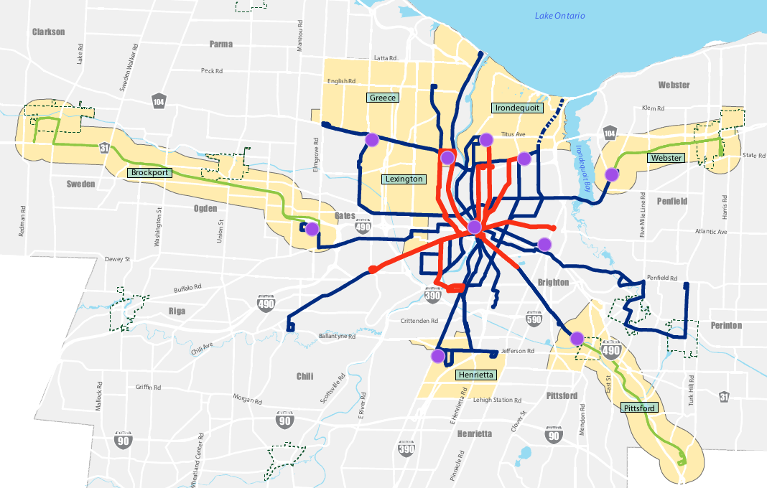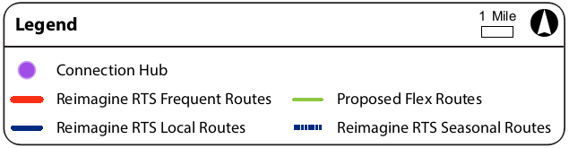

RTS On-Demand Service
RTS on-demand is a dial-a-ride service provided to the public on accessible vehicles. Dial-a-ride is a type of demand responsive service that operates in a CMZ area during set days and hours. Pickups and drop-offs can occur anywhere in the CMZ, so customers can arrange to travel to and from specific locations. Customers must make a request for service and arrange a pickup time. RTS will develop the schedules and routes for a particular day based on the requests. Customers can use RTS on-demand to arrange for transport from a location in the CMZ to a connection hub, where they can transfer to fixed route service or complementary paratransit to complete their trip the core network. When returning from the core network, customers use fixed route or paratransit to travel to a connection hub. Customers contact RTS to arrange for on-demand transport from the connection hub to their destination within the CMZ. While the demand responsive services like RTS on-demand do not require complementary paratransit service, the level of service provided to customers with disabilities and to customers without disabilities shall be equivalent. RTS on-demand is available in the following CMZs: Greece, Lexington, Henrietta, and Irondequoit.

RTS Flex Service
RTS flex is a route deviation service available to the public on accessible vehicles. Route deviation is a type of demand responsive service that operates along an established route in a CMZ area during set days and hours. The route has designated stops. Between the designated stops, vehicles deviate from the established route to pick up or drop off customers within a ¾ mile radius of the route. Customers must contact RTS to request an off-route pickup. A general recommendation is to call one to two hours in advance of the desired pickup time. Traveling between scheduled stops on the established route does not require a request in advance. Customers can use RTS flex to travel from a connection hub to a designated stop in the CMZ or request to be dropped off at a location up to ¾ miles off route in the CMZ. Customers can also use RTS flex to travel to a connection hub, where they can transfer to RTS fixed route service or complementary paratransit to complete their trip in the core network. When returning from the core network, customers use fixed route or paratransit to travel to a connection hub. Customers can transfer to RTS flex service and travel to a designated stop or request an off-route drop-off. While the demand responsive services like RTS flex do not require complementary paratransit service, the level of service provided to customers with disabilities and to customers without disabilities shall be equivalent. RTS flex is available in the following CMZs: Brockport, Pittsford/Eastview, and Webster.

Personal Mobility On-Demand Service
Personal mobility on-demand service (PMOD) is another type of demand responsive service. PMOD service is for individuals and small groups up to five persons traveling between various origins and destinations along a dynamic itinerary formed in response to customer reservations. PMOD service is an option for customers traveling within CMZs during hours when RTS flex and RTS on-demand are not in service.

Brockport Community Mobility Zone
The Brockport CMZ will provide service in areas affected by the proposed discontinuation of the current Route 104 Brockport in the towns of Ogden and Sweden and the villages of Brockport and Spencerport. This proposed 30.56 square-mile zone, the largest of the CMZs, focuses on the relatively more populated areas north of NY Route 31. This zone will provide an important link between Rochester and the College at Brockport, State University of New York campus (SUNY Brockport) through a transfer to the fixed route network at a Connection Hub located at the Rochester Tech Park in the Town of Gates. The Brockport CMZ offers RTS flex service starting at a connection hub near Rochester Technology Park in Gates and travels northwest along 531 and 31 through Ogden and continues to several destinations in Sweden. The CMZ boundary includes the Villages of Brockport and Spencerport. Key destinations in the CMZ include Rochester Tech Park, the Village of Spencerport, Lifetime Assistance, Frances Apartments, Woodlands Apartments, and retail on Owens Road, Brockport retail corridors, Sweden Senior Center, A.D. Oliver Middle School, the College at Brockport, and Brockport High School. The hours of service for RTS flex are 6:00 AM to 10:00 PM during weekdays and 6:00 AM to 7:00 PM on weekends and holidays. Personal mobility on-demand (PMOD) service is available in the same corridors and boundaries from 5:00 AM to 6:00 AM and 10:00 PM to midnight during weekdays and from 7:00 PM to midnight on weekends and holidays.
Customers using RTS fixed route can take the local service route serving Jay and Maple to the connection hub near Rochester Technology Park. At the hub, customers can transfer to RTS flex or PMOD service to travel within the Brockport CMZ. Similarly, customers can use RTS flex or PMOD to reach the hub and transfer into the RTS fixed route service for trips to Jay Street between Broad and Child, and Maple Street between Child and Mount Read. Where Jay Street meets West Broad Street, customers can use bus stops to transfer to Short Line service to the RTS Transit Center.
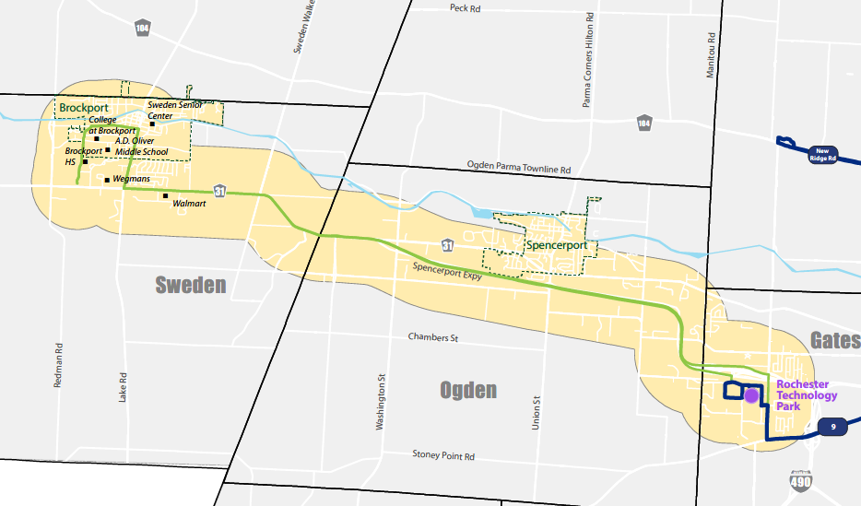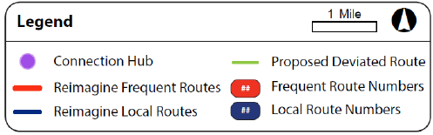

Greece Community Mobility Zone
The Greece Community Mobility Zone will provide service to residents and businesses in the town of Greece where 40-foot bus service has been determined to be infeasible. The 24.35 square-mile CMZ is bisected by the I-390 expressway and encompasses major retail locations such as The Mall at Greece Ridge and Northgate Plaza, as well as a site of higher education in Bryant & Stratton College. Several major roads define the boundary of the Greece CMZ. North Greece Road forms the west boundary; West Ridge Road forms the south boundary; Lake Avenue forms the east boundary; and Edgemere Drive, Dewey Avenue, and English Road form the north boundary. It is possible to connect to fixed route service on Lake Avenue and to the Port of Rochester and Ontario Beach Park area. In the Port of Rochester area, customers can connect to the Irondequoit CMZ. The Greece CMZ has a connection hub near Eastman Business Park. Key destinations in the CMZ include The Mall at Greece Ridge (with fixed route connections), Bryant and Stratton College, Kodak Park, Northgate Plaza, Affinity Orchard Apartments, Ridge Road retail corridor, Latta Road corridor, retail and shopping centers (Wegmans, Walmart), Ontario Beach and Charlotte recreation facilities, K-12 schools.
The Greece CMZ offers RTS on-demand service and PMOD service. The hours of service for RTS on-demand are 6:00 AM to 7:00 PM Monday to Sunday and holidays. PMOD service is available in the same corridors and boundaries from 5:00 AM to 6:00 AM and 7:00 PM to midnight Monday to Sunday and holidays.
The fixed route local long line service for Lake Avenue travels along the east boundary of the Greece CMZ to Ontario Beach Park. The fixed route local long line service on Dewey Avenue travels into the Greece CMZ and continues to the Dewey Walmart. The Crosstown fixed route service on West Ridge Road travels the west boundary between the Elmridge Center and the connection hub at Eastman Business Park. The fixed route local long line service for Lyell Avenue travels from the RTS Transit Center to Lyell Avenue, and on to Spencerport Road, Long Pond Road, Parkridge near Park Ridge Hospital and Park Ridge Living Center, returns to Long Pond, and continues on West Ridge Road to Greece Ridge Mall.
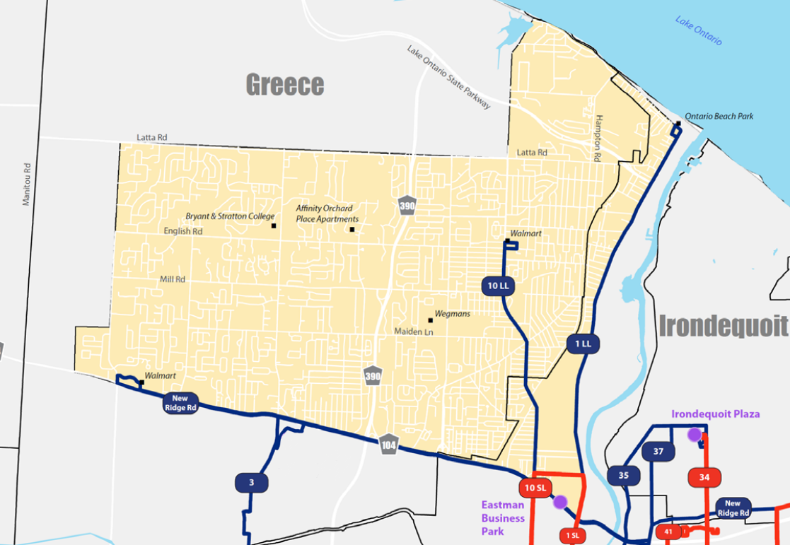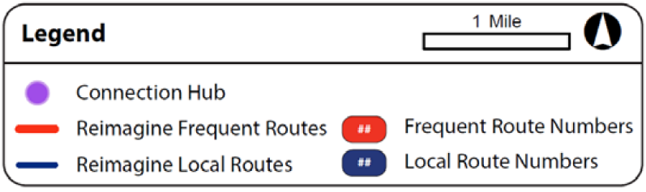

Henrietta Community Mobility Zone
The Henrietta CMZ will provide connections beyond the fixed-route network to destinations within the Town of Henrietta. The Henrietta CMZ is a 19.57 square-mile area located south of the City of Rochester. The CMZ is bisected by the I-390 expressway, Jefferson Road (252) and West Henrietta Road (15) and is home to regional retail destinations, such as Marketplace Mall, Southtown Plaza, a Walmart Supercenter and Frontier Commons. The Henrietta CMZ area is defined as the Town of Henrietta north of Lehigh Station Road and includes core retail and commercial areas of Henrietta and residential and service destinations. Lehigh Station Road forms the south boundary, Jefferson Road and Henrietta-Brighton Town Line Road forming the north boundary, Pinnacle Road forms the east boundary, and West Henrietta Road forms the west boundary. A connection hub near Marketplace Mall allows customers to transfer to or from the Culver Crosstown or Marketplace local fixed route service and use RTS on-demand or PMOD within the CMZ.
The key destinations in the Henrietta CMZ include Marketplace Mall and Henrietta retail core, Jefferson Road corridor, the Henrietta Town Hall, the Henrietta Town Library, the Future Veterans Administration Outpatient Facility on Calkins Road, and dispersed senior, affordable or assisted housing and student housing locations throughout the CMZ.
The Henrietta CMZ offers RTS on-demand service 6:00 AM to 7:00 PM Monday to Sunday and holidays. PMOD service is available in the same corridors and boundaries from 5:00 AM to 6:00 AM and 7:00 PM to midnight Monday to Sunday and holidays. The fixed route Culver Crosstown connects Irondequoit to Marketplace Mall by way of Skyview on the Ridge to Culver Road, Parsells Avenue, Goodman Street, MCC, and East Henrietta Road. The fixed route local service for Marketplace serves West Henrietta Road and Jefferson Road via Marketplace Mall.
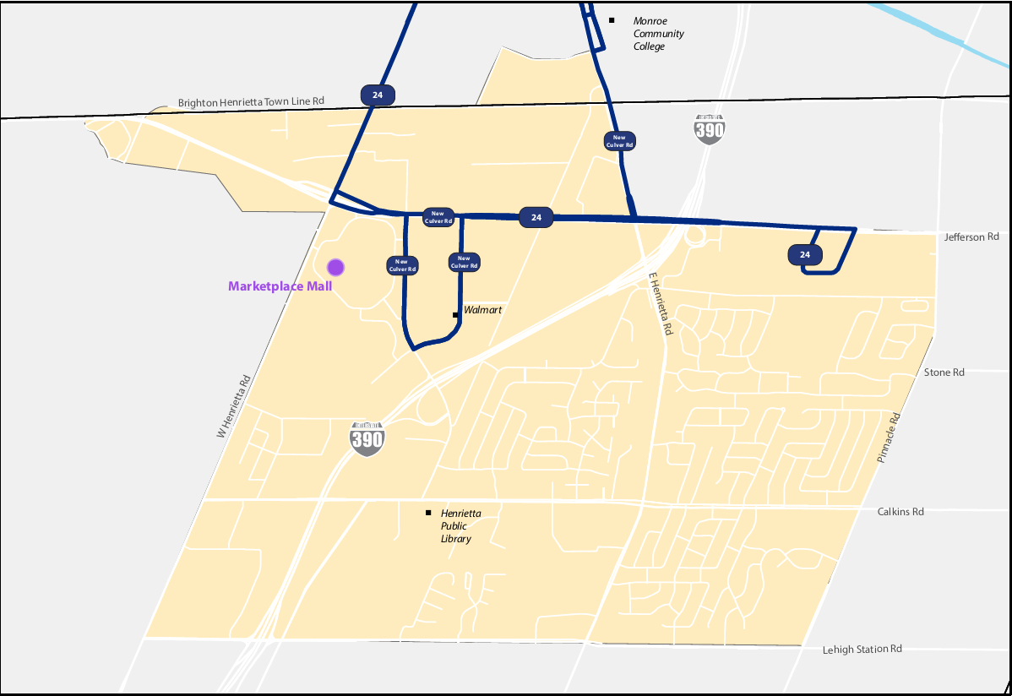

Irondequoit Community Mobility Zone
The Irondequoit CMZ is outlined by the Genesee River and the Irondequoit town line on the west; by Lake Ontario to the north; Irondequoit Bay to east; and East Ridge Road, Seneca Avenue, and Long Acre Road to the south. The 12.12 square-mile area includes or is near several recreational and cultural opportunities, including Ontario Beach, Seneca Park Zoo, Durand Eastman County Park and Seabreeze Amusement Park. The southern portion of the CMZ includes connections to fixed route transit. There is a connection hub near Irondequoit Plaza and a connection hub near Skyview on the Ridge. The Culver Crosstown fixed route service travels into the CMZ and connects to a seasonal route traveling to Seabreeze Amusement Park.
The key destinations in the Irondequoit CMZ include the Skyview on the Ridge, Rochester Regional Health, Ridge/Titus retail corridors, Wegmans, Irondequoit Plaza, Pattonwood Drive, Irondequoit Bay Park, West Irondequoit High School, Dake Middle School, Seabreeze Amusement Park, and Lakeshore communities and attractions. The Irondequoit CMZ offers RTS on-demand service 6:00 AM to 7:00 PM Monday to Sunday and holidays. PMOD service is available in the same corridors and boundaries from 5:00 AM to 6:00 AM and 7:00 PM to midnight Monday to Sunday and holidays. Portions of the fixed route local service for St. Paul, North Clinton, and Hudson travel into the CMZ and go to the connection hub near Irondequoit Plaza. Portions of the fixed route frequent service for Portland and the local service for Goodman travel into the CMZ and go to the connection hub near Skyview on the Ridge. The Culver Crosstown and Ridge Road Crosstown also travel along the southern boundary of the Irondequoit CMZ. The Ridge Road Crosstown continues to travel along the southern boundary of the Greece CMZ and goes to the Eastman Business Park connection hub.
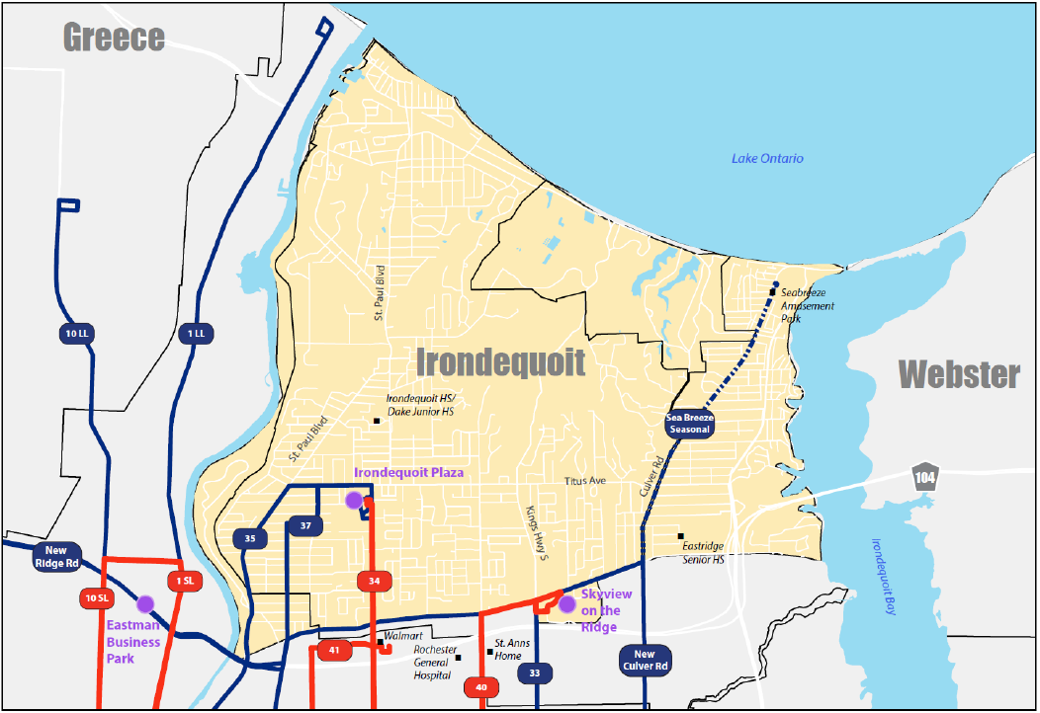

Lexington Community Mobility Zone
The Lexington CMZ represents a mostly industrial area within the City of Rochester. At 8.89 square miles, the Lexington CMZ is the smallest by area but major employers are located within the Zone, as well as community services such as FoodLink. The Lexington CMZ is the area within the following boundaries: Ridge Road to the north; Dewey Avenue to the east; Lyell Avenue to the south; and Long Pond Road to the west. The Zone partially overlaps with the Greece CMZ along Ridge Road West.
The zone also extends south beyond Lyell Avenue and into an area surrounded by Mt. Read Boulevard and Cairn Street to the west, Chili Avenue to the south, and Hague Street to the east. The Lexington CMZ contains one connection hub near the Eastman Business Park. Key destinations in the Lexington CMZ include the Lexington Avenue Industrial Corridor, Eastman Business Park, LiDestri Foods, Love Beets, Edison Career and Technology High School, community services such as FoodLink, and Greece Ridge Mall.
The Lexington CMZ offers RTS on-demand service 6:00 AM to 7:00 PM during weekdays only. PMOD service is available in the same corridors and boundaries from 5:00 AM to 6:00 AM and 7:00 PM to midnight during weekdays only.
Access to fixed route service is possible along the north, south, east, and west edges of the zone.
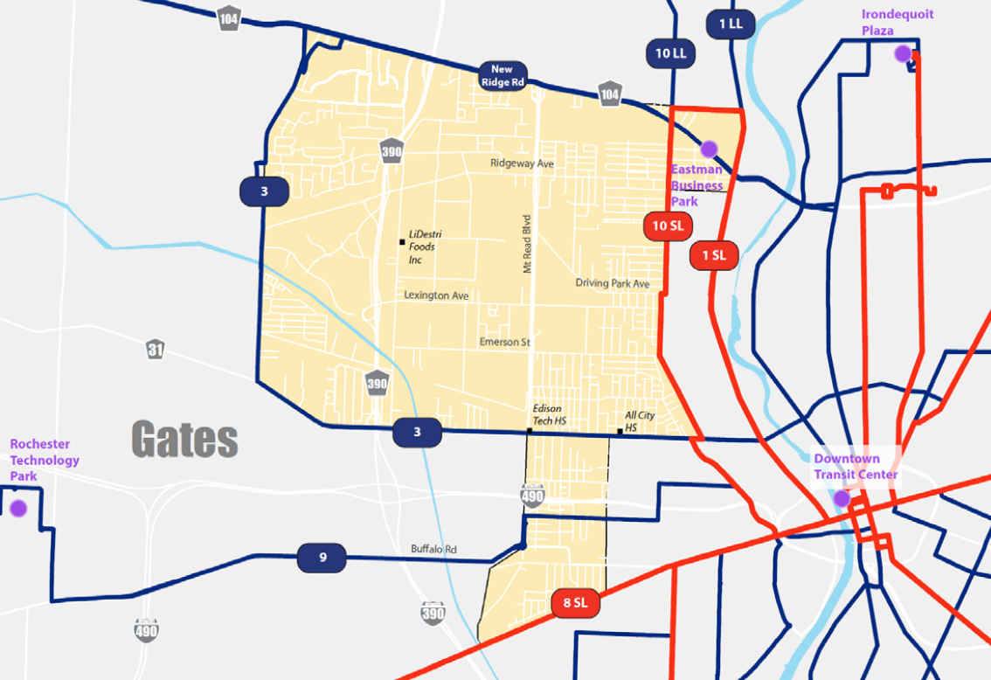

Pittsford and Eastview Community Mobility Zone
The Pittsford/Eastview CMZ contains the New York Route 96 corridor between Eastview Mall and the Town of Pittsford. The Eastview CMZ offers RTS flex service starting at a connection hub near Concentrix Corporation and travels between Pittsford Plaza in the Town of Pittsford to Eastview Mall in Victor, (Ontario County) along NYS Routes 31 and 96. The primary route travels along Monroe Avenue and Route 31 into the Village of Pittsford, where it continues southeast along Route 96 through Bushnell’s Basin to Eastview Mall. Route deviations are typically up to ¾ of a mile on either side of the main route, but expands to include the area near the intersection of Clover Street and Jefferson Road. This allows service to key destinations including St. John Fisher College and Cloverwood Senior Living.
Key destinations in the CMZ include Nazareth College, St. John Fisher College, the Village of Pittsford, Cloverwood Senior Living, Concentrix Plaza, Pittsford Plaza, Pittsford Sutherland High School, Pittsford Mendon High School, Southeast Family Branch YMCA at Clover and Jefferson, Eastview Mall retail corridor, and Eastview Mall park and ride. The hours of service for RTS flex are 6:00 AM to 7:00 PM Monday through Sunday. PMOD service is available in the same corridors and boundaries from 5:00 AM to 6:00 AM and from 7:00 PM to midnight Monday to Sunday.
The fixed route local long line service for Monroe Avenue continues into the CMZ and goes to the connection hub near Concentrix Corporation.
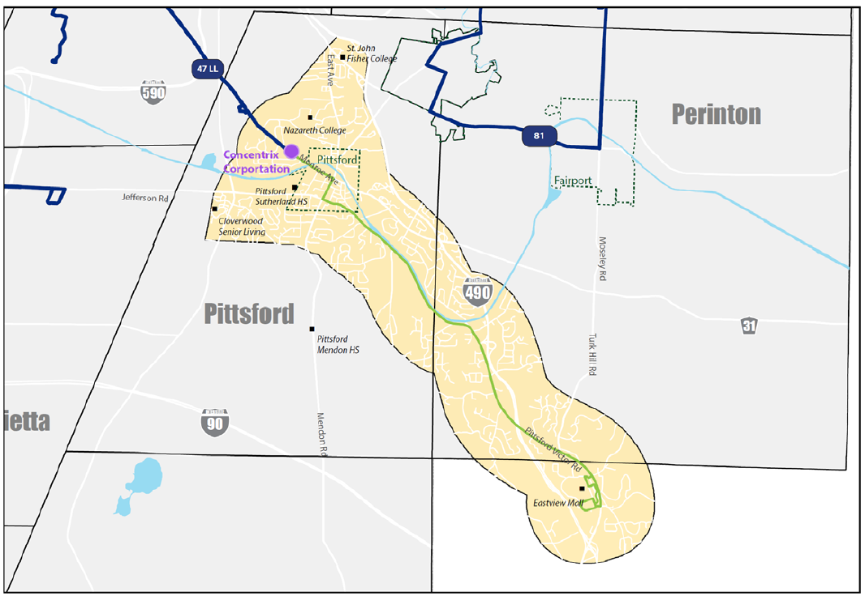

Webster Community Mobility Zone
The Webster Community Mobility Zone provides connections to the fixed-route system through a connection hub at BayTowne Plaza in Penfield. The 10.8 square-mile Zone has important retail and commercial corridors along Ridge Road, in the village center and is home to a Xerox facility. The Webster CMZ offers RTS flex service for the area that runs between BayTowne Plaza in the Town of Penfield and Phillips Village (Phillips Road) in the Village of Webster along Empire Boulevard and Ridge Road. Route deviations are permitted within ¾ of a mile on either side of the main route, plus within the Village of Webster. This includes a northerly extension that encompasses the Xerox Webster site. The connection hub is located near BayTowne Plaza.
Key destinations in the CMZ include Ridge Road retail and service corridor, BayTowne Shopping Center, the Town Center at Webster, the Webster Town Hall, Phillips Village, Hill Haven on Empire Boulevard, Basket Road, the Village of Webster, apartment complexes on Hold Road and Hard Road, and the Xerox Webster campus.
The hours of service for RTS flex are 6:00 AM to 7:00 PM Monday through Sunday. PMOD service is available in the same corridors and boundaries from 5:00 AM to 6:00 AM and from 7:00 PM to midnight Monday to Sunday.
The fixed route local service for Webster continues into the CMZ and goes to the connection hub near BayTowne Plaza.
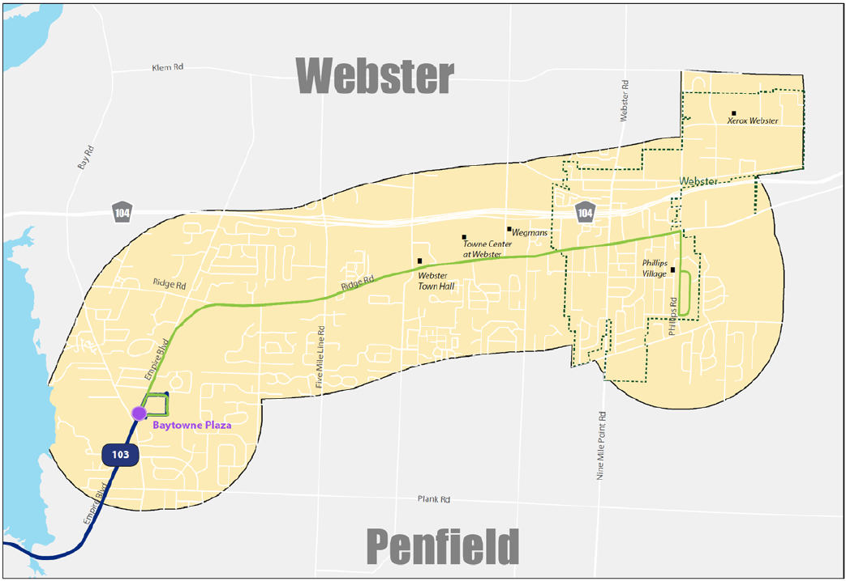

RTS Access Paratransit Service Areas
RTS Access provides A D A complementary paratransit services to complement the fixed route services of RTS in Monroe County. We propose three levels of supplemental paratransit service to support travel in the Community Mobility Zones and the suburban areas.
We suggest using the interactive online map at https://arcg.is/0unvvv along with other resources available to you such as assistive technologies or friends, family, attendants, in order to better understand where points of interest (addresses) are in the proposed areas.
The Required Area is color-coded green, has a required level of service, runs 5:00 AM to midnight on weekdays, runs 6:00 AM to midnight on weekends, and costs $2 per trip.
The Supplemental Level 1 area is color-coded blue, has a required level of service, runs 5:00 AM to midnight on weekdays, runs 6:00 AM to midnight on weekends, and costs $2 per trip.
The Supplemental Level 2 area is color-coded orange, has a required level of service, runs 5:00 AM to 7:00 PM on weekdays only, and costs $5 per trip.
The Supplemental Level 3 area is color-coded gray, offers a supplemental level of service only, runs 5:00 AM to 7:00 PM on weekdays only, and costs $8 per trip.

Weekday Service Area
Weekday paratransit service includes four areas, each with unique characteristics. The areas are categorized as the Required Area and three supplemental service levels (Level 1, Level 2, and Level 3). The supplemental service may change if so authorized as a resolution from the Board of Commissioners.
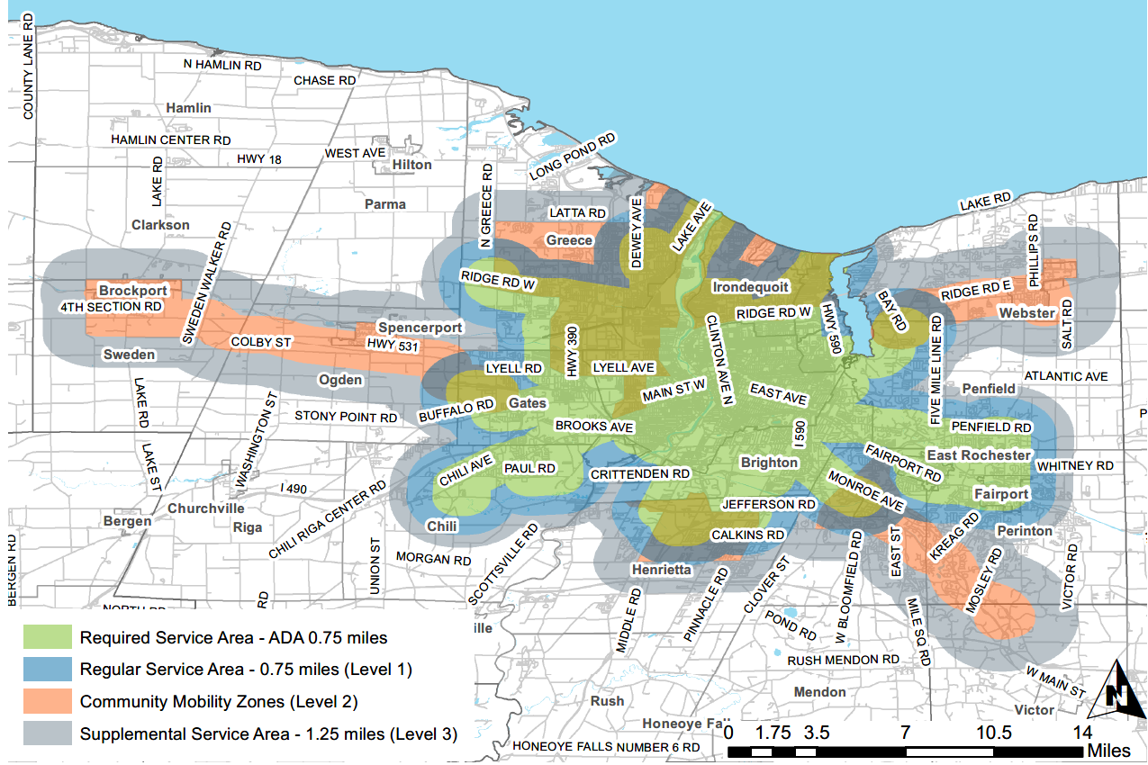
The Required Area surrounds the fixed route service and is shown on the map as a large green “blob” shape. By federal requirements, we are required to provide complementary paratransit service in this area. The Required Area is a corridor with a width of ¾ of a mile on each side of each fixed route. At the end of a route, there is a semicircular “cap” on the corridor, consisting of a ¾- mile radius from the endpoint of the route to the parallel sides of the corridor. We will provide paratransit service to any origin or destination point within a corridor fitting this description around any fixed route in the RTS system. The weekday service hours for the Required Area are Monday through Friday from 5:00 AM to midnight.
For Level 1, Level 2, and Level 3, we propose supplemental services with varying characteristics.
Level 1 is shown on the map as a thick blue outline surrounding the green blob. The supplemental service in Level 1 goes ¾ miles beyond the ¾-mile Required Area, for a total service area of 1 and ½ miles. We will do our best to serve Level 1 as though it is in the Required area and will call it the Regular service area. When you book a trip in the Regular area, you can negotiate pickup times and reserve rides up to five days ahead. We will guarantee a ride with a one-day advance reservation. The weekday hours for Level 1 are Monday through Friday from 5:00 AM to midnight.
If you travel to the RTS Transit Center to use fixed route for some trips, we will perform drop-offs and pickups at Clinton Avenue, at the RTS Transit Center plaza.
Any part of a Community Mobility Zones goes outside Required Area and Regular Area (Level 1) is considered Level 2. The map shows each Community Mobility Zone as an orange shape that corresponds to the geographic boundaries of the zone. Parts of each shape are hidden because the Required Area or Level 1 covers it. The Level 2 areas are the visible orange portions. The Required Area and Level 1 overlap with the Greece, Henrietta, and Irondequoit CMZs. We do our best to serve Level 2 as though it is in the Required Area. When you book a ride in Level 2, you can negotiate pickup times and reserve rides up to five days ahead. We will guarantee a ride with a one-day advance reservation. The weekday hours for Level 2 are Monday through Friday from 5:00 AM to 7:00 PM, excluding holidays.
If you ride RTS on-demand or RTS flex from a location in Level 2 to a location in the Regular or the Required Area, show your Access ID to the Driver to ride free of charge. Once you are in the Required or Regular area, you can be picked up by RTS Access. The same is true for a return trip.
Level 3 supplemental service will be in a set geographic area which is 1.25 miles around the Required Area and/or Level 2 at the time of Board approval of the Paratransit Plan for 2020. Note, however, that the Level 3 geographic area will not be subject to change, either smaller or larger, in the event of potential subsequent changes in the Required Area and/or Level 2. It is shown on the map as a thick grey outline around Levels 1 and 2. The supplemental service will be provided only if space is available after scheduling rides in the Required Area, Level 1, and Level 2. You can make reservations 1 day in advance only and trips are not guaranteed. The weekday hours for Level 3 are Monday through Friday from 5:00 AM to 7:00 PM, excluding holidays.
You can take Subscription trips in the Required Area, Level 1, and Level 2.

Weekend Service Area
Weekend paratransit service includes the Required Area and Level 1.
If you ride RTS on-demand or RTS flex from a location in Level 2 to a location in the Regular or the Required Area, show your Access ID to the Driver to ride free of charge. Once you are in the Required or Regular area, you can be picked up by RTS Access. The same is true for a return trip.
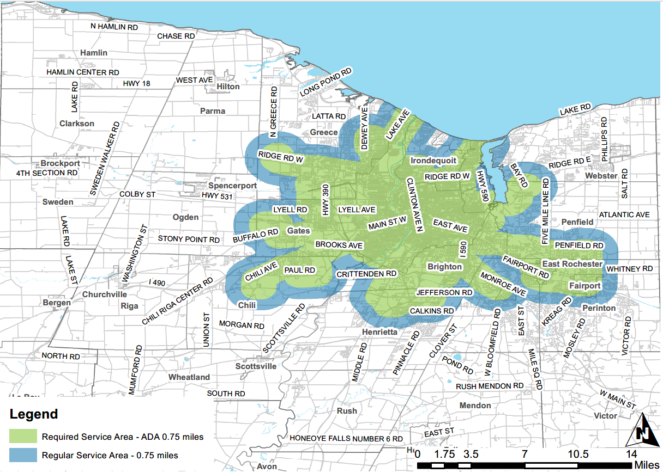
The Required Area surrounds the fixed route service and is shown on the map as a large green “blob” shape. The weekend hours for the Required Area are Saturday and Sunday from 6:00 AM to midnight and include holidays.
Level 1 is shown on the map as a thick blue outline surrounding the green blob. The supplemental service in Level 1 goes ¾ miles beyond the ¾-mile Required Area, for a total service area of 1 and ½ miles. We will do our best to serve Level 1 as though it is in the Required area and will call it the Regular service area. When you book a trip in the Regular area, you can negotiate pickup times and reserve rides up to five days ahead. We will guarantee a ride with a one-day advance reservation. The weekend service for the Regular Area are Saturday and Sunday from 6:00 AM to midnight and include holidays.
You can take Subscription trips in the Required Area, Level 1, and Level 2.
If you travel to the RTS Transit Center to use fixed route for some trips, we will perform drop-offs and pickups at Clinton Avenue, at the RTS Transit Center plaza.

Service Hours

RTS Fixed Route Service Hours
RTS fixed route service runs from 5:00 AM to midnight on weekdays, from 6:00 AM Saturday morning to midnight Sunday, and from 6:00 AM Sunday morning to midnight Monday.
The RTS Transit Center facility is open Monday through Friday from 4:30 AM to midnight and Saturday to Sunday from 5:30 AM to midnight.
The Customer Information Desks at the RTS Transit Center have staff available on Monday through Friday from 6:15 AM to 7:45 PM.
The RTS Administration Building lobby is open to the public Monday through Friday from 8:00 AM to 5:00 PM and closed on weekends and holidays.
The RTS Customer Service Center Representatives are available Monday through Sunday from 5:00 AM to midnight.

RTS Access Paratransit Service Hours
RTS Access will mirror the service hours of RTS fixed route service, including on holidays. We will follow a weekend schedule during New Year’s Day, Memorial Day, Independence Day, Labor Day, Thanksgiving Day, the Day after Thanksgiving, and Christmas Day.
Weekday hours for the Required Area and Regular Area (Level 1) are Monday through Friday from 5:00 AM to midnight.
Weekday hours for Level 2 are Monday through Friday from 5:00 AM to 7:00 PM, excluding holidays.
Weekday hours for Level 3 are Monday through Friday from 5:00 AM to 7:00 PM, excluding holidays.
Weekend hours for the Required Area and Regular Area (Level 1) are Saturday and Sunday from 6:00 AM to midnight, including holidays.

Scheduling Hours
The RTS Access Schedulers will book rides occurring during the same hours and days as RTS fixed route services. The RTS Access Scheduling office is open from 8:00 AM to 5:00 PM Monday through Friday. Scheduling hours for Saturday, Sunday, New Year’s Day, Memorial Day, Independence Day, Labor Day, and Thanksgiving Day will be from 8:00 AM to 1:00 PM. The Scheduling office will be closed on Christmas day.
RTS Access has a phone line for scheduling (reserving) trips. To request a trip, customers must dial 585-224-8330, and press 3 at the prompt.
RTS Access has received funding to upgrade the reservation system to allow online reservations. The software product called “PASS Web” will provide customers of RTS Access with the online reservation capability to confirm, cancel, and book their own trips over the Internet.
RTS Access has phone lines for questions or requests unrelated to trip reservation. Customers can reduce hold times for those who are scheduling trips by using the appropriate phone lines designated for other types of calls. These phone numbers are online at https://www.myrts.com/RTS-Access/Calling-RTS-Access.
The Dispatch office is open 4:00 AM to 1:00 AM Monday through Friday and 5:00 AM to 1:00 AM on weekends. The Dispatchers’ primary job is to support bus operations. During Scheduling office hours, they will transfer trip requests to Scheduling. Dispatchers will schedule same-day trips when the Scheduling office is closed.

Fares

RTS Fixed Route Fares
You must show your RTS Access ID Smartcard to the RTS Driver or tap the smartcard on the fare box to ride the fixed routes free of charge. If you ride RTS on-demand or RTS flex from a location in Level 2 to a location in the Regular or the Required Area, show your Access ID to the Driver to ride free of charge.
Children age five and under ride free with a limit of three children per each fare-paying adult.
RTS does not charge fare for service animals traveling with their handlers or pets traveling with their owners (pets must be in carriers).
People with disabilities who are not eligible for RTS Access will pay a cash fare of $0.50 (with Reduced Fare card) to ride RTS buses.
The “31 Day Senior or Disabled” pass is $28.00.
The “All Day Senior or Disabled” pass is $1.50.
The “5 Day Senior or Disabled” pass is $7.00.
The Stored Value Pass is $10.00 when purchased online. Stored Value Passes can be purchased in $5, $10, $15, $20 at ticket vending machines.

RTS Access Paratransit Fares
The proposed fares for RTS Access paratransit are: $2.00 per trip in the Required and Regular (Level 1) Areas on weekdays and weekends; $5.00 per trip in Level 2 during weekdays; and $8.00 per trip in Level 3 during weekdays. Same-day service costs $6.00 in addition to the base fare per trip. The higher fares for supplemental service in Level 2 and Leve1 3 are allowable per the regulations.
RTS Access proposes to discontinue the $18 Value Pass. You will be able to purchase paratransit $20 Value Passes. RTS Access proposes to stop the Rider Rewards Program. Instead, when you buy a $20 Value Pass you will get $22 worth of fare. The options for purchasing fares are explained in the full Paratransit Plan.
If you have Conditional or Temporary eligibility, you can ride any RTS fixed route service free by tapping your RTS Access Photo ID Smartcard on the farebox reader when you board.
An eligible visitor must pay the correct fare for an RTS Access trip and show proof of eligibility or visitor status to board the RTS Access bus.
A single personal care attendant (PCA) must ride the same trip with the customer or visitor to board the RTS Access bus. The PCA does not pay a fare.
A single companion must pay a fare for the trip and ride the same trip with the customer or visitor to board the RTS Access bus. Additional companions must pay a fare for the trip and ride the same trip with the customer or visitor if space is available.
RTS Access does not charge fare for service animals traveling with their handlers or pets traveling with their owners (pets must be in carriers).

Accessibility

RTS Fixed Route
The regulation 49 CFR A Part 37, Subpart G – Provision of Service covers the topic of fixed route accessibility.
RTS complies with the Americans with Disabilities Act requirements because 100% of the buses are accessible and all new routes are accessible. The city or town usually is in charge of the accessibility features in the area where an RTS bus stop is located (such as curbing, curb cuts, crosswalks, concrete pads).
All 220 of the RTS buses are accessible. They accommodate wheelchairs and other mobility devices. They have ramps and “kneelers” that lower the bus to ground level. They have audio and visual stop announcements.
RTS offers free training to people who would like to learn about using fixed route service. There is no charge for this program, which can be customized to meet specific needs. For more information, contact RTS at (585) 654-0739.
Priority seats are at the front of buses for seniors and people with disabilities. RTS Drivers must ask other customers to offer the priority seats to seniors and people with disabilities. But, the RTS Drivers cannot force people without disabilities to leave the priority seat if they do not want to.
RTS buses have areas for people to secure their mobility devices during the ride. RTS Drivers must ask customers to clear the areas for people using mobility devices. Shopping carts, bicycles, and skateboards are not mobility devices. A few examples of mobility devices are manual wheelchairs, motorized wheelchairs, walkers, canes, or crutches.
Drivers will lower the RTS buses to make boarding as easy as possible for everyone. Customers can request the lift or ramp at any RTS bus stop. RTS Drivers will ask customers to stay 4 to 5 feet back to allow the ramp to lower.
RTS Drivers are required to secure all mobility devices. It is the Driver’s responsibility to verify that the securement and release of a mobility device is performed properly for the safety of all. If an aide, personal care attendant (PCA), or other customer performs the securement or release, please ask the Driver to check it. Mobility devices must be secured with 3-4 point securements anytime they are on the bus.
RTS encourages customers to use the shoulder and lap belt for safety. Drivers will ask customers in mobility devices if they would like assistance with securing the shoulder and lap belt (vehicle seat belt). RTS Drivers must not apply the vehicle seatbelt to people in mobility devices if they decline it or if it is not possible to secure the mobility device in a way that is acceptable to the customer and the Driver. For safety, RTS encourages customers to lock manual wheelchairs or to turn off motorized mobility devices. RTS must provide transportation to wheelchair users even when the device does not have brakes; or when the person chooses to leave the wheelchair unlocked; or when the person choose not to set the brakes; or when the person chooses to leave the device turned on.
A stop request button is on the priority seat. Pressing the button tells the RTS Driver that a person with a mobility device will need to get off the bus. Customers who need to use the ramp will exit from the front doors of the bus.

Accessible Formats and Language Assistance
We will communicate in accessible formats. We will make sure information about eligibility certification, recertification reminders, warnings, suspension notices, or appeals is provided in a format that people can use. We will track requests and provide the appropriate formats consistently.
Instructions for making a request are available in the full Paratransit Plan. You can also use the online Contact Us form available at https://www.myrts.com/Contact-Us.

Summary of Paratransit Operational Policy Changes

Subscription Service Summary
The full text of the Subscription policy is in Exhibit 4 of the Paratransit Plan.
“Subscriptions” allow you to set a schedule of repeated trips. We expect all customers to follow these rules:
- Use your Subscription trips.
- Cancel Subscription trips six days ahead.
- Tell us if you miss a trip and it is not your fault.
- Recertify or renew your eligibility on time.
- Six days before you go on vacation or take a day off for a holiday, put your Subscription on hold.
To qualify for a Subscription, you must have All-Trip or Conditional certification and you must take one or more identical trips per week. Identical trips have the same origin and destination and the same pick-up or drop-off time on the same day or days of the week.
The policy provides instructions for requesting a Subscription. If we have capacity we will provide a new Subscriptions will begin 21 days after you request it. If we do not have capacity, we will add you to the waiting list.
We will offer Short-term Subscriptions. Short-term Subscriptions last three weeks to 90 days. You cannot change or place a short-term subscription on hold.
We will excuse situations when you miss or cancel a trip due to a reason outside your control. This includes sudden illness, a personal, household, or medical emergency, or needing to care for a sick family member. This also includes operational or scheduling errors. The full policy provides instructions for notifying us.
You can put your Subscriptions on hold for up to three months. When a Subscription is on hold, you can stop using temporarily so you can go on vacation or celebrate a holiday. You need to request the hold six days before you need to stop using the Subscription. The full policy provides instructions for requesting a hold. You will need to call us within three months to resume your Subscription trips as usual. Otherwise, your Subscription will be revoked.
If you use the Subscription service and your schedule changes, you will need to reapply. The full policy provides instructions for reapplying.
The full policy explains what can cause the loss of a Subscription. If you had a temporary hold applied to your Subscription, but failed to resume using it after your hold period ended, we will revoke the Subscription. If we identify a pattern of absenteeism or excessive cancellation, we will revoke your Subscription.. The first time you receive a Repeated Service Infraction, we will revoke your Subscription and tell you the date to begin scheduling every trip. We may revoke any Subscription that is canceled 30% or more in two consecutive months. You cannot miss more than seven Subscription trips in one month. The decision to revoke a Subscription because of excessive cancellations is final. If you are suspended, the suspension will apply to all paratransit trips, including Subscription trips. If you have a trip Subscription but allow your Conditional eligibility certification to expire, we will revoke the trip Subscription privilege on the date of expiration.
If we revoke your Subscription service, you may request to reinstate that service or apply for a new Subscription 60 days after the date the Subscription was revoked. You must not have any Service Infractions during that period. If you qualify and capacity is available, we will reinstate the Subscription or create a new Subscription. If the Subscription requests exceed capacity, availability, or peak demand, we will add you to a waiting list.
If your Subscription service has been revoked due to Repeated Service Infractions three times within 18 months, you will no longer qualify for Subscription service.
Subscription service will not exceed more than 50% of the number of trips available at a given time of day, unless there is non-subscription capacity. Subscription trips will not run on these major holidays: New Year’s Day, Memorial Day, July 4th, Labor Day, Thanksgiving Day, and Christmas Day. RTS Access does not provide Subscription service on any day that RTS determines is a holiday (i.e. floating holiday).
Subscriptions will not be available for unique trips, or during hours or days with peak demand; to customers with Temporary eligibility certifications; or for trips in Level 3 of the paratransit service area.
The full policy describes rights reserved regarding changes in Subscription service due to capacity constraints, loss of efficiency, or the need to preserve effective operations.

Service Area Change Notification Summary
The full text of the policy is available in Exhibit 5 of the Paratransit Plan.
After the 2020 redesign, RTS fixed route service may undergo route overhauls, service changes, or major service changes. The RTS system may undergo system-wide adjustments or incorporate new products.
The change may result in the reduction of service, the expansion of service, or alteration of the service area. This type of change must be approved by the Board. Whenever RTS implements an approved service change that affects its routes or service area, the change will be replicated in the RTS Access complementary paratransit service area.
If fixed route service change reduces the service area for RTS Access complementary A D A paratransit, RTS Access will identify the customers affected and issue a written notification to each customer explaining the change. The notification will include a list of alternate transportation providers.
We propose to notify customers at least 30 days before the effective date of the change. Anyone who is affected will have an interim period of at least 120 days from notification or 90 days from the effective date—whichever is later. You may use the interim period to implement new arrangements to meet your travel needs while continuing to schedule trips with RTS Access to destinations affected by the service change. After the interim period ends, RTS Access will schedule trips within the defined service area only.
It will be the your responsibility to arrange for alternate transportation to reach pick-up points within the RTS Access service area or to travel from the RTS Access service area to any destination outside the service area.
You will be asked to provide signed acknowledgement regarding the change and their responsibilities.
We may also contact affected customers via Interactive Voice Response audio to notify them about the change, to notify them about the requirement to make alternative arrangements within the interim period, and to relay information about alternate transportation providers.
We will log when an affected customer is notified and whether the customer provided the acknowledgement as requested. Customers who do not provide acknowledgement will still be subject to the service change.
We will not grant extensions or retro-activity.

Service Infractions and Suspensions Summary
The text of the full policy is in Exhibit 6 of the Paratransit Plan.
We will track Service Infractions. Service Infractions include: 1) not showing up for the ride (No-Show), 2) cancelling less than two hours before the Pickup Period (Late Cancellation), and 3) refusing the ride when the bus arrives for your pickup (Cancel at Pickup).
We will track Repeated Service Infractions cumulatively through the entire calendar year until December 31. We will excuse situations when you miss or cancel a trip due to a reason outside your control. You are responsible for notifying us about these situations before the 15th of the following month. The full policy gives instructions for notifying us. You can also notify us if you think you received a Service Infraction due to operational or scheduling error.
Every customer starts the calendar year on January 1 with zero Repeated Service Infractions. Every customer starts the 1st day of a month with zero Service Infractions. On the 15th of each month, we will evaluate your actual usage of reserved trips during the prior month.
Step 1: Make all the exclusions. We will exclude any trip that you missed due to a reason beyond your control and we excused from being a Service Infraction before the 15th. We will exclude any individual trips that you canceled one or more days ahead of the scheduled pickup date. We will exclude any Subscription trips that you canceled six or more days in advance of the trip date. We will exclude any Subscription trips that you put “on hold” six or more days in advance of the trip date.
Step 2: Add the Service Infractions to get the total number for the prior month.
Step 3: Compare the total. If the total number of Service Infractions is less than three, the trip usage is acceptable and no further calculation is necessary. If the total number of Service Infractions is greater than or equal to three, we will calculate the percentage of missed trips.
Step 4: Calculate the percentage of missed trips. Divide the Service Infractions by the total trips in the prior month. Multiply the total by 100 to calculate the percentage of missed trips.
Step 5: Compare the percentage of missed trips to 5%. If the missed trips are less than 5%, the trip usage is acceptable. If the missed trips are greater than or equal to 5%, you will get a Repeated Service Infraction.
If 5% or more of the trips resulted in Service Infractions for that month, we will apply penalties as defined in the full policy. The buildup of Repeated Service Infractions is the basis for a Service Suspension. RTS Access will add the number of times a customer has a Repeated Service Infraction in one calendar year to determine the penalty. The calendar year starts on January 1 and ends on December 31. The first Repeated Service Infraction in one calendar year will result in a penalty of a Warning Letter. The subsequent Repeated Service Infractions in one calendar year will result in service suspensions of increasing length, starting with five days but not exceeding 20 days. If you get a Repeated Service Infraction in the last two months of the calendar year, the penalty might occur in the next calendar year, even though the tracking mechanism restarts for each calendar year. Any Repeated Service Infraction will cause you to lose any Subscriptions you have. You can ask to restore the Subscription or apply for new Subscription service 60 days after the original revocation date. If Subscriptions are revoked three times during a period of 18 months, you will no longer qualify for Subscription service. We will provide any warnings, suspension notifications, or information about the appeals process in an accessible format.
If you appeal a notice of service suspension, we will continue to provide paratransit service as usual to the you while the appeal is pending.

Service Suspensions for Prohibited Conduct Summary
The full policy is available in Exhibit 6 of the Paratransit Plan.
Customer use of RTS Access paratransit service is subject to compliance with R G R T A’s Rules of Conduct for Transit Vehicles, Facilities, and Properties (“Rules”). These Rules are intended to regulate conduct occurring on R G R T A transit vehicles, within or upon R G R T A facilities and properties, including the RTS Transit Center, and in connection with R G R T A’s provision of public transportation services. These Rules apply to all transit conveyances and facilities, including paratransit service.
On RTS Access, the Americans with Disabilities Act permits the suspension of customers from the service who engage in violent, seriously disruptive or illegal conduct towards other customers (passengers), Drivers, or RTS Access staff, or R G R T A staff. RTS Access customers are responsible for the conduct of their Personal Care Attendants and/or companions, including children. The full policy provides a list of prohibited conduct.
RTS Access reserves the right to suspend customers who engage in violations of the Rules of Conduct for Transit Vehicles, Facilities, and Properties to the extent permitted by A D A and/or to issue summonses when such conduct is observed by a police officer or other officer duly designated to issue summonses.
RTS Access shall enforce, exclude from service, and provide notice of exclusion (suspension) in accordance with the procedures identified in “Article IV. Enforcement” of the Rules of Conduct for Transit Vehicles, Facilities, and Properties (“Rules”). The appeals process shall be provided to any person excluded (suspended from service) for a period of 31 days or more. The Appeal Procedure is provided in the Rules and shall apply. RTS Access will provide paratransit service to the appellant during the appeal process. Except for suspensions for violent or seriously disruptive conduct, before suspending service, RTS Access will notify the customer in writing. The notice will identify the specific conduct leading to the suspension and the duration of the suspension. The customer will have an opportunity to be heard and to present information and arguments as to why the suspension should not be imposed. Following this process, RTS Access will notify the customer in writing of the final decision and the reasons for it. In the case of suspensions for violent or seriously disruptive conduct during a paratransit trip, the suspension will take effect immediately, but the customer will be entitled to a post-suspension appeal. The same appeal procedures noted above will be followed.

No Strand Summary
The full policy is in Exhibit 9 of the Paratransit Plan.
Circumstances, such as a medical appointment taking longer than expected, may prevent you from showing up during the 5-Minute Waiting Period for your return trip. If you miss your originally scheduled return trip, and request another pickup, we will do our best to schedule a return trip. It is important to know the following:
The Policy applies to the return ride of a round-trip during service hours; and, we will only schedule trips during regular service hours; and, you may need to wait longer than you would normally wait for a pickup. Another option is to call 585-224-8330, Option 3, to request a Same-day trip. If we have availability, we will schedule the ride. You will need to pay the additional cost of same-day service plus your fare
A “Final Pickup Period” is the latest available pickup period for a return trip. The final pickup period is based on the comparable schedule for fixed route service, takes into account the likely travel time for the requested trips and allows us to finish transporting customers to their destinations no later than the latest comparable fixed route drop-off. For example, if the latest drop-off on a particular RTS fixed route is 10:30 PM, we could establish a return-trip Final Pickup Period of 9:50 PM to allow the Bus Drivers to complete the return trips by 10:30 PM.

Eligibility Summary
The full policy is available in Exhibit 11 of the Paratransit Plan.
We propose the following eligibility certification types: All-Trip, Conditional, and Temporary. The term “All-Trip” will replace the term “Unconditional.” The All-Trip Certification grants you eligibility to use paratransit for all trips in the service area because the condition preventing you from functionally using fixed route service is unlikely to improve, and external improvements are unlikely to provide you with the functional ability to use fixed route for some of your trips. All-Trip Certifications must be renewed every three years. The renewal consists of a basic form to obtain updated contact information and note any changes in your travel abilities or needs. The renewal process also allows us replace your Tap &Go Access ID card if necessary. The renewal does not involve recertification. The renewal form will request the date, your date of birth, your name, your preferred phone number, your email address, your mailing or residential address, and the name and phone number of your emergency contact. The form will also ask if you use a mobility device, PCA, or service animal, whether any of your travel needs have changed, whether you would like your Access ID card inspected for replacement, whether you require information in an alternate format, and whether we should send information to you or to a designated representative.
Previously, the “Seasonal” eligibility certification was for October through April. But, we felt this practice did not consider seasonal conditions during other months of the year. As a result, “Seasonal” will not exist as a separate eligibility category. We propose to include seasonal conditions as part of the wider set of conditions that can cause barriers to travel and result in a determination of Conditional eligibility.
We revised the Conditional eligibility category to adhere more clearly to the Code of Federal Regulations set forth in Part 37 Transportation Services for Individuals with Disabilities (A D A). As Appendix D to § 37.123 explains, “A person may be A D A paratransit eligible for some trips but not others. Eligibility does not inhere in the individual or his or her disability, as such, but in meeting the functional criteria of inability to use the fixed route system established by the A D A. This inability is likely to change with different circumstances.” Conditional eligibility applies to individuals who are able to independently use fixed route transit service under some circumstances. Rather than basing Conditional eligibility on the degree to which a person’s specific disability could change, we are assessing a wide assortment of conditions, such as weather, season, and the physical characteristics of the location, to identify whether there are barriers that can affect travel. The full policy explains that a person’s functional ability to use fixed route service may increase or decrease based on specific, measurable conditions. The A D A Certification Coordinator will provide individuals with a description of the conditions under which he or she can use paratransit, as well as the basis for the eligibility determination.
When a person is certified or recertified as paratransit eligible, the A D A Certification Coordinator will send information about rights under Title VI along with the eligibility materials. We will provide recertification messages, renewals, eligibility determinations, and Title VI information in an appropriate accessible format. Applicants and customers can call 585-654-0608 during regular office hours for additional assistance.
If you believe your functional abilities have changed and the conditions established no longer reflect your abilities, you can submit new documentation, or reapply at any time during the current term of eligibility.
The full policy provides instructions for appealing a decision to deny eligibility or for appealing the type of eligibility granted.
The text for the Application for Eligibility Certification is provided in the Paratransit Plan. The text for the proposed Renewal form for All-Trip Eligibility is provided in the Paratransit Plan.

Appeal Procedure Summary
The full text of Appeal Process and Procedure is available in Exhibit 11 of the Paratransit Plan.
If you appeal a notice of service suspension, we will provide paratransit service as usual while your appeal is pending, including Subscription service.
If you appeal the eligibility decision or the type of eligibility granted, we will NOT provide paratransit service during the process. After completing the process, we will have 30 days to issue the decision. If we take longer than 30 days to issue the appeal decision, we must provide paratransit service to you until we issue the appeal decision.
Applicants who are found ineligible for paratransit or who dispute the eligibility determination of Conditional or Temporary eligibility shall have the right to appeal the determination. An appeal form is included with the determination.
Certified eligible paratransit customers suspended from service for incurring Repeated Service Infractions shall have the right to appeal the service suspension determination. An appeal form is included with the determination.
Certified eligible paratransit customers suspended from service for 31 days or more due to Prohibited Conduct under the Rules of Conduct shall have the right to appeal the service suspension determination. The customer can submit an appeal in writing.

Appealing a Determination of Ineligibility or a Certification Type
Individuals must mail or deliver the appeal form so that RTS Access receives the appeal form no later than 60 days from the date in the body of the notification letter.
The appellant has the right to be heard in-person for the appeal. At his or her discretion, the appellant may elect to include the reasons for the appeal along with the appeal request form. The appellant may choose to submit written information in advance of a scheduled appeal hearing. The appellant may bring a representative of his or her choice to assist in the presentation of the appeal.
The appellant may elect to submit written basis for the appeal rather than attend the scheduled appeal hearing in person. During the scheduled hearing, the written information will be reviewed.
We are proposing a simpler, shorter form for appealing an eligibility decision. The full text of the form is described in the Paratransit Plan. The form asks for your name, phone number, mailing address, client ID number. The form gives you two choices for your appeal participation. You can submit information for the Paratransit Appeals Committee to read but you will not appear in person. Or, you can choose to appeal in person and come to the hearing. The form asks for the date of the eligibility decision you are appealing. The form gives you two choices for the decision you want to appeal. You can appeal the determination of eligibility or you can appeal the type of eligibility.

Appealing a Service Suspension Issued for Repeated Service Infractions
Individuals must mail or deliver the appeal form so that RTS Access receives the appeal form no later than 14 days from the date in the body of the service suspension letter. If the individual files an appeal before the suspension start date, RTS Access postpones the suspension during the appeal process. If the individual’s suspension included revoking a trip subscription, the revocation is also postponed during the appeal process.
The appellant has the right to be heard in-person for the appeal. At his or her discretion, the appellant may elect to include the reasons for the appeal along with the appeal request form. An appellant may appeal the basis for a proposed suspension even if he or she elects not to dispute any individual Service Infraction. The appellant may choose to submit written information in advance of a scheduled appeal hearing. The appellant may bring a representative of his or her choice to assist in the presentation of the appeal.
The appellant may elect to submit written basis for the appeal rather than attend the scheduled appeal hearing in person. During the scheduled hearing, the written information will be reviewed.
We are proposing a simpler, shorter form for appealing a service suspension due to Repeated Service Infractions.
The form asks for your name, phone number, mailing address, client ID number. The form gives you two choices for your appeal participation. You can submit information for the Paratransit Appeals Committee to read but you will not appear in person. Or, you can choose to appeal in person and come to the hearing. The form asks for the date of the suspension notice you are appealing.

Hearings for Eligibility Determinations or for Service Infraction Service Suspensions
RTS Access shall develop a pool of Paratransit Appeals Committee members (hereafter referred to as “the Committee”). RTS Access may recruit members from any source that R G R T A deems appropriate so long as the individuals selected are not involved in the RTS Access initial determination processes for eligibility or for service suspension. Due to the nature of the information that will be presented during hearings for Appeals of Eligibility, all Committee members will be required to sign a non-disclosure agreement.
The Committee shall meet at least once per month. Appeals received by RTS Access shall be scheduled to be heard at the next scheduled meeting of the Committee.
RTS Access will work with the appellant to find a mutually convenient time for the hearing. Once a hearing is scheduled, it cannot be rescheduled unless the appellant provides justification for why he or she is unavailable on the scheduled hearing date. RTS Access reserves the right to request evidence of the appellant’s unavailability including letters from doctors, employers or other professionals. If the appellant is unavailable on the originally scheduled hearing date and can provide a justifiable cause, RTS Access will reschedule the hearing for the following month. RTS Access will allow one such scheduling exception per appeal.
RTS Access shall provide appellants with advance notice of the hearing date in an accessible format. The notice shall communicate the following information:
- The date, time, and location of the scheduled hearing; and
- The appellant may elect to bring a representative of his or her choosing to assist in the appeal; and
- The appellant has the right to present any new evidence, orally or in written form, that he or she believes supports his or her eligibility for paratransit services, or which supports his or her right to continued paratransit services.
If an appellant requests to appear in person for the hearing, but does not appear for the scheduled hearing, the appellant must contact the Paratransit Appeals Coordinator at 585-654-0200 within 24 hours of the missed hearing date and provide justification for the absence. If the appellant provides sufficient justification for the absence, the hearing will be rescheduled for the following month. RTS Access will allow one such scheduling exception per appeal.
If the appellant does not contact the Paratransit Appeals Coordinator within 24 hours of the hearing and provide sufficient justification for the absence:
- The appellant will waive the right to appear in person for a hearing on his or her appeal of a service suspension or an eligibility decision; and
- The Committee will base its decision on the appeal’s merit and the decision will stand.
RTS Access shall select three members from the Committee pool to preside over each Committee hearing in advance of the hearing. Prior to the scheduled hearing, RTS Access shall provide each member with the docket of appeals to be heard. RTS Access may elect to provide the Committee members with information regarding the scheduled appeals in advance of the hearing. If RTS Access elects to provide such information, the same information shall also be provided to the appellant.
RTS Access shall require that each Committee member inform RTS Access of any personal, financial, or professional relationships the member has with the appellant.
If a Committee member declares a personal, financial, or professional relationship with an appellant, RTS Access shall remove the member from the panel hearing the individual’s appeal, and shall replace the member with another member who does not have any personal, financial, or professional relationship with the appellant.
Hearings shall be conducted in a manner that provides the appellant with a fair opportunity for presenting reasons or evidence that support his or her position. The appellant must be given the opportunity to respond directly to each reason cited by RTS Access to justify an eligibility determination or order of service suspension.
During the hearing, the Committee will consider the appeal based on the merits of the appeal, written evidence (if available), and in-person statements (if available).
The regular order of the hearing will be as follows:
- Opening of hearing;
- Introduction of parties;
- Presentation of RTS Access ineligibility, eligibility type, or suspension rationale;
- Presentation of the appellant’s rationale for his or her position;
- Questions from the Committee members;
- Closing of the hearing, including an explanation of the decision issuance process.
The hearings are intended to be informal proceedings. No formal rules of evidence or formal administrative law or judicial procedures apply. The regular order of the hearing outlined herein shall not preclude the Committee from deviating from it in cases where doing so is in the best interests of fairness, or necessary to obtain the information to render an informed decision.
After the hearing closes, the Committee shall deliberate until it reaches a decision regarding the appeal. The Committee shall exclude both the appellant and staff presenting RTS Access’s position from the deliberative process.
The Committee may elect to have an RTS Access staff person present to provide administrative support. Any RTS Access staff present 1) shall not have any relationship with the processes for determining ineligibility, eligibility type, or service suspension; and 2) shall not be a supervisor or subordinate of the person making the ineligibility, eligibility type, or service suspension determination.
A decision shall be reached by majority vote of the three-person panel. In reaching a decision, the Committee shall consider the RTS Access paratransit eligibility guidelines, applicable RTS Access rules and procedures, and all evidence presented by RTS Access and by the appellant. Each Committee member shall indicate his or her vote and rationale on a form provided by RTS Access. The Committee’s decision shall be final.
RTS Access shall issue a written decision in an accessible format to the appellant within 30 days of the hearing date. The decision letter shall be prepared by an individual whom is neither 1) involved in the ineligibility, eligibility type, or suspension determination; nor 2) a supervisor or subordinate of the person making the determination. The decision letter shall accurately reflect the decision of the Committee. If the decision upholds RTS Access’s initial determination of ineligibility, eligibility type, or service suspension, the written decision shall explain in detail the Committee’s rationale for the decision.
If a written decision pertaining to an appeal of ineligibility is not issued within 30 days of the hearing, RTS Access shall deem the individual eligible for paratransit services until a written decision is issued.
RTS Access shall maintain a complete and accurate record of each appeal hearing. The full policy lists each of the components retained as a record.

Appealing a Service Suspension Issued for Prohibited Conduct
RTS Access shall enforce, exclude from service, and provide notice of exclusion (suspension) in accordance with the procedures identified in R G R T A’s Rules of Conduct for Transit Vehicles, Facilities, and Properties (“Rules”).
The appeals process shall be provided to any person excluded (suspended from service) for a period of 31 days or more due to prohibited conduct.
Not later than ten calendar days after commencement of the suspension, an excluded person may appeal in writing to the R G R T A Chief Executive Officer or designee, for a new review of the suspension. Commencement of the suspension shall be the date upon which the suspension became effective and shall be determined by R G R T A’s official records. The appellant may request a hearing or may request review without a hearing based on a written statement setting forth the reasons why the suspension is invalid or improper. If the excluded person is unable to respond in written format, R G R T A will make reasonable accommodation to allow due process. The CEO shall convene a Hearing Panel comprised of three persons selected as follows:
- The Manager of Transit Center Operations or designee;
- The Manager of Service Delivery or designee;
- The Director of Service Delivery or designee; or
- A person selected from the R G R T A staff by the Chief Operating Officer or designee.
The said R G R T A staff person shall be a person other than the Chief Executive Officer. The decision of the majority of the members of the Hearing Panel shall be the decision of the Hearing Panel. The Hearing Panel shall hear the appeal, or if no hearing is requested, review the matter based upon the record, and render a written decision within twenty calendar days after the receipt of the appeal. The decision of the Hearing Panel shall be final. If a hearing is requested, the hearing shall be held within twenty calendar days after receipt of the appeal, and a written decision shall be rendered within twenty calendar days after the hearing. RTS Access will provide paratransit service to the appellant while the appeal decision is pending, including transportation to the hearing if necessary.

Reserving Rides Summary
An individual trip has one outgoing ride with a single origin (pickup) and single destination (drop-off). Such a trip has one part, which can be explained as going from point A to point B. A round trip has two booked rides, first outgoing from an origin to a destination, and then returning from the same destination to the same origin. A round trip has two parts. Each trip must be requested and reserved explicitly with the RTS Access staff. A multi-part trip connects several parts. A multi-part trip requires a reservation for each part.
When you reserve a ride, the Scheduler will need to know the origin, destination, desired pick-up time, the number of people traveling (i.e. PCA or companion), the number of service animals traveling, and whether you will have a mobility device. You have the right to travel with PCAs, service animals, mobility devices, and assistive devices according to your needs. Your answers will help the Schedulers to book a trip on a vehicle best suited for all the components to which each customer is entitled, especially during busy times of the day.
You must reserve the ride at least one day in advance to ensure a ride in the Required Area, Level 1, or Level 2. This is “Next-Day” service. For trips in Level 3 of the service area (available during weekdays only), you can book one day in advance but the trip is not guaranteed and will be on a space-available basis. RTS Access will document any instance when it is unable to accommodate a ride request made the previous day.
We will not limit the number of trips per day or trips per person that can be made. With the exception of Trip Subscriptions, we will not use waiting lists.
You will have the option to book a ride up to five days in advance for trips in the Required Area and supplemental trips in Level 1 and Level 2. You can book up to six rides (three round trips) in advance during the same phone call. Booking rides in advance is an option, not a requirement. We recommend booking in advance to ensure getting the rides but we will accommodate same-day trip reservations if space is available.
The Scheduler will ask “What time do you want to be picked up?” The Scheduler may negotiate pickup times, but cannot require customers to schedule their trip to begin more than one hour before or after the requested time. RTS Access will document any instance when it cannot schedule the ride within a one-hour window of the time requested. After negotiating the pickup time, the Scheduler will communicate the pickup period to the customer.
RTS Access will take steps to ensure that it provides timely pickups within 20 minutes of the scheduled time (5 minutes prior and 15 minutes after). Travel time on paratransit service will be comparable to the amount of time it would take to make the same trip using RTS fixed-route bus service with connections. When you have two or more rides on the same day, we will require a minimum of 60 minutes (1 hour) between each drop-off and pickup time.
To encourage timely service, on-time performance will continue to be measured for RTS Access in the Transit Operations Performance Scorecard (TOPS)

Pickup Period (Window) Summary
A pickup period is the window of time during which you can expect the bus to arrive for the pickup time. The window will start five minutes before the pickup time and end 15 minutes after the pickup time. After the pickup period begins, the Driver will wait five minutes for you to show up for the booked ride. If the Driver arrives before the pickup period begins, the Driver will wait until the starting time of the pickup period and, if you have not yet appeared, then wait the additional five minutes.
For example, if the bus arrives at 1:12 PM for a 1:30 PM pickup, Driver must wait until the pickup period starts at 1:25 PM. If the customer does not appear at 1:25 PM for boarding, the Driver must wait for a full five minutes to elapse (1:30 PM) before departing.

On-Time Performance Summary
Customer feedback shows that on-time performance (OTP) is a strong indicator of service quality and correlates to customer satisfaction. RTS Access established an OTP goal of 95.0% in 2018. We may adjust the goal annually to provide an accurate measure of quality. We use technology, data points, and calculations to determine the on-time performance each month. Management monitors the results to identify ways to improve performance. You can provide input about on-time performance through the RTS Access Bus Service Questionnaire or the online Contact Us form available at http://rts.force.com/RTSContactUs. Here is a description of the questionnaire. An example of the questionnaire is fully described in Exhibit 8 of the Paratransit Plan.

Questionnaire
On a scale of 1-5 where 1 means “Very Dissatisfied” and 5 means “Very Satisfied” please rate your overall level of satisfaction with RTS Access’s performance on the following elements of bus service: overall performance, if the bus arrives on time, if the schedulers are courteous, if the drivers are courteous, the ease of buying passes or paying fare, the ease of contacting RTS Access. The questionnaire also allows you to rate your overall level satisfaction with overall cleanliness and the level cleanliness for seats, windows, floors, and the outside of the bus. The questionnaire asks how often you ride the RTS Access bus per week and how long you have used paratransit. The questionnaire asks you to pick one of the following options as being the most important to you: bus arrives on time, or comfort of the bus, or driver courtesy, or easy to get information, or safety and security, or a clean bus, or scheduling. The questionnaire provides additional space for other comments.

Early Departures Summary
It is the Driver’s responsibility to wait until the pickup window starts before counting down the five minutes. An “Early Departure” occurs if the Driver departs before the pickup window starts. If you miss your trip due to an early departure, please report it to us. We will excuse the missed trip when the Driver departs early. You can use any of these phone numbers to report early departures.
- Dispatch Office, 585-654-0675
- Scheduling Office, 585-224-8330, Option 3
- Cancellations or No-Shows, 585-654-0647
- Operations, 585-654-0747
If the bus arrives at 1:30 PM for a 1:30 PM pickup and you are not ready to board, the Driver will wait for a full five minutes to elapse. If the bus arrives at 1:44 PM you are not ready to board, the Driver will wait for a full five minutes to elapse. If you are not actively boarding the bus by minute five, the Driver will report a missed trip and proceed to the next pickup location.
If the bus arrives 16 minutes or more after the pickup time, we will require the Driver to notify Dispatch. The bus will be considered late. If the late arrival will affect customers, we will do our best to contact and notify them of the issue. We will document any instance when we are late for a scheduled pick up.

Time Between Trips Summary
RTS Access will require customers to stay a minimum of one hour between the drop-off at any destination and a return trip. The FTA guidance acknowledges that transit agencies may separate two trip requests by 60 minutes and, in some instances, 90 minutes. Every trip involves a pickup time, pickup window, and travel time. When a customer reserves a trip, the Schedulers need to know the origin, destination, time of travel, the number of people traveling, and the number of service animals. The FTA rules prohibit RTS Access from prioritizing one type of trip over another (excluding subscription trips). While it may seem sensible to allow the Driver to wait a short period for one customer to perform an errand and return to the bus, doing so could delay the pickup or drop off for another customer. Allowing the Drivers to wait for some trips, but not for all trips, is not compliant with the regulations. As a shared ride service, RTS Access will strive to operate in a manner that is consistent for all trips.

Canceling Rides
We expects you to use your booked rides. We expect you to cancel any ride you do not need in advance.
You must cancel rides by phone. Drivers will not be able to cancel rides. You will have the ability to cancel rides 24-hours a day, 7-days a week by leaving a voice-mail message with your ride information. You can call 585-224-8529 or 585-224-8330, Option 1. When cancelling a round trip, the you will need to cancel the pickup ride and the return ride. We will not cancel the return ride automatically.
We will expect you to cancel an individual ride at least two hours before the pickup period starts. An “Advance Cancellation” is when the you call and cancel the ride at least two hours in advance of the pickup. Advance Cancellations will not carry any penalty.
A “Late Cancellation” will occur if the you cancel a ride less than two hours ahead of the pickup period. We will count a Late Cancellation as a Service Infraction unless you notify us that the situation was beyond your control.

Traveling with Companions Summary
You have the right to travel with one accompanying companion during the trip. The accompanying companion must travel the same trip as you.

Traveling with Children Summary
You have the right to bring one child as the accompanying companion. If space is available and children do not displace other eligible riders with reserved trips, you may bring more companions, including children. It is important to discuss the number of companions when scheduling the ride. We recommend that you tell the Scheduler when you will need to travel with multiple children. Discussing the size of the group will ensure the trip includes the full group and does not infringe on the rights of other customers, who may be traveling with PCAs or companions on that same trip.
Safety is an important reason for discussing children with the Scheduler. The Scheduler may need to ask the age of the children accompanying you. Some paratransit rides are booked on sedans. New York State law requires that children under the age of four ride in child safety seats and that all children ride in child safety restraint systems until their 8th birthday. For safety, we will not transport children in sedans if they are younger than 8 years and/or are physically smaller than recommended. The child must weigh at least 80 pounds and measure 4 feet, 9 inches in height. Knowing the age of the accompanying children will allow the Schedulers to reserve the ride on the appropriate vehicle.

Traveling with Personal Care Attendants Summary
You have the right to travel with one Personal Care Attendant (PCA) who assists you with a daily life activity. The PCA must travel the same trip as you do. A friend or family member is a PCA if the customer regularly makes use of a PCA and the friend or family member is actually acting to assist the customer with personal needs. We realize that a child may act as a your PCA. In these cases, we recommends that you explain to the Scheduler that your PCA is a child when you schedule the trip. This is not a requirement. Giving the information to the Scheduler will better ensure that the Driver knows that the you will board with a child acting as the PCA.
If you bring a PCA on your trip, the you have the right to bring one child or one adult as an accompanying companion.

Traveling with Service Animals Summary
You have the right to travel with your service animals. Schedulers may ask if you will bring your service animal on a trip. The purpose of this question is to help ensure adequate space for the service animal along with other customers sharing that ride (as well as their accompanying companions, PCAs, and devices). The FTA considers this question to be an acceptable practice.
The regulations allow us to ask if the animal is a service animal, or ask what tasks the animal has been trained to perform. The regulations prohibit us from asking anyone to describe or demonstrate his or her disability, and from asking for proof of the service animal’s certification or identification.
Caring for a service animal is the responsibility of the customer or PCA. RTS and RTS Access Drivers will not take charge of a service animal.
Service animals must not block the bus aisle. It is your responsibility to position service animals so that other customers can use the aisle safely. RTS and RTS Access Drivers may ask customers to adjust the position of the service animal if all or some of the animal blocks the aisle and prevents safe passage for other customers. Service animals must not pose a direct threat to the health and safety of others. Under such circumstances, RTS and RTS Access may deny service until the service animal is under control.
RTS and RTS Access will treat a request for a service animal to sit on the seat next to you or in the your lap as a reasonable modification, provided the service animal is under your control at all times and does not disrupt service (i.e. displace paying customers).
Comfort Animals or Emotional Support Animals do not qualify as service animals under the Americans with Disabilities Act. You can travel with these animals, but RTS and RTS Access will apply the same requirements as are applied to pets.

Restroom Request Summary
RTS Access Drivers will grant occasional requests to interrupt the trip if you have an urgent need to use a restroom before reaching your planned destination. We will expect customers to make such requests out of necessity rather than personal convenience. The Driver will work with Dispatch to locate a safe place for you to exit the bus and access a public restroom. If scheduling and safety conditions allow, the Driver may wait at the location for you to return. However, in the interest of operating consistently, the Driver may need to continue with the next pickups and drop offs as scheduled, and return to pick you up in a reasonable period of time to finish your original trip.

Requests for Reasonable Modification Summary
RTS and RTS Access shall make reasonable modifications to policies, practices, and procedures when such modifications are requested and necessary to avoid discrimination based on disability. RTS and RTS Access shall deny any request that will create a direct threat to the health or safety of others; or fundamentally alter the nature of services, programs, or activities; or result in an undue financial and administrative burden. RTS and RTS Access may deny a requested modification if the individual with a disability is able to use services, programs, or activities for their intended purpose without the requested modification. RTS and RTS Access will expect customers to call and request reasonable modifications in advance when possible. This is particularly appropriate where a permanent or long-term condition or barrier is the basis for the request. This process will allow RTS and RTS Access to make the necessary determinations in advance of the need for modified service. When doing so, RTS and RTS Access will expect customers to describe what they need in order to use the bus service (but will not require customers to use the term “reasonable modification” when making the request). Applicants for paratransit service can include the request for reasonable modification during the eligibility process. Otherwise, customers may make modification requests directly to the Driver at the time they are needed.
RTS and RTS Access operating personnel will make a determination whether the modification should be provided at the time of the request. Operating personnel may consult with management before making a determination to grant or deny the request. Many locations represent a direct threat to safety if the Driver attempts to drive in reverse (back up). If the safety of a location has not been assessed, and a customer requests a reasonable modification that requires the bus to back up, the Driver will work with Dispatch to determine the best way to assist the customer. RTS or RTS Access will then follow-up with a safety assessment of the location. If, after a safety assessment, backing the bus up in that location is deemed a direct threat to the safety of others, RTS or RTS Access will notify the customer and the Drivers that future requests requiring the bus to back up in that location will be refused, even if the original request was accommodated.
RTS and RTS Access will not provide personal care attendants or personal care attendant services to meet the needs of customers with disabilities during their trips. If a customer requests assistance with carrying a single bag or package, RTS and RTS Access will consider the request a reasonable modification. However, requests that would require the Driver to make multiple trips or to carry several items fundamentally alter the Driver’s function. As a result, RTS and RTS Access will direct the Driver to decline such requests.
If a customer requests the Driver to remain at a destination because the customer cannot be left alone without an attendant, RTS and RTS Access will direct the Driver to decline the request because it would fundamentally alter the Driver’s function to provide personal care attendant service of this kind.
For the same reason, RTS and RTS Access will direct Drivers to decline requests to reach into pockets or backpacks to extract fare media or to lift the customer into or out of a mobility device such as a wheelchair or scooter (hand-carry). RTS and RTS Access will direct Drivers to decline requests to carry an individual or support the full weight of an individual.

Door-to-Door Assistance
RTS Access will grant a reasonable request for door-to-door assistance as a reasonable modification to its curb-to-curb service. There must be a safe place to park the bus or sedan on a public roadway or parking lot, and, the path between the vehicle and destination entrance must be safe and accessible. When parked, the RTS Access vehicle cannot block or impede traffic.
RTS Access makes an important distinction between door-to-door and door-through-door assistance. During door-to-door, the Driver provides assistance from the curb to the door of the destination, or from the external door of building to the curb where the you can board the bus. However, the Driver will not assist you through the door into the building or enter a building to assist you to the exit. Helping you through the door into or out of the building or residence is the type of assistance provided by a PCA, and is outside the Driver’s function. As a result, RTS Access will instruct Drivers to decline requests to assist the you through the door of a building or to enter the building to assist you. The Driver may open a public building’s external door or operate the door activation push button. The Driver will not unlock a locked door, operate a paging system, or accompany you to or from a waiting room or reception area. You are responsible for making sure another person or PCA is available to assist you in such situations.

Complaint Procedure Summary
The text of the complaint forms is available in Exhibit 7 of the Paratransit Plan.

Reasonable Modification
If you believes RTS or RTS Access has not complied with the requirement to make a reasonable modification, you can file a complaint within 30 days after the date of the alleged violation. The customer can either file a hardcopy form through the United States Postal Service or send the form as an electronic file online. The Reasonable Modification Complaint form is available online at https://www.myrts.com/Riders-Guide/A D A-Compliance#resmodnon. Customers can also request the form by calling Customer Service or RTS Access Scheduling.
To send a hardcopy complaint, print and complete the Reasonable Modification Form. Mail the Reasonable Modification Form via USPS to the following address: R G R T A Legal Affairs Department, 1372 East Main Street, Rochester, NY 14609.
To send the complaint electronically, download the form and complete it. Create an electronic copy of the form (for example, a scanned PDF). Use the online Contact Us form available at http://rts.force.com/RTSContactUs to initiate a complaint, attach the completed Reasonable Modification Complaint form, and submit the complaint.
R G R T A will provide general assistance, language, or disability assistance during administrative business hours. Call 585-654-0771 to request general assistance. Call 585-288-1700 to request language or disability assistance.
R G R T A will conduct a review based on the submitted facts, the written complaint, and ask additional questions if necessary. R G R T A will issue a decision in writing within 30 days after the date of the review. You may also file a complaint directly with the Department of Transportation, Departmental Office of Civil Rights, 1200 New Jersey Avenue SE, Washington, DC 20590. Phone: 202-366-4648 or TTY/Assistive Device: 202-366-9696.

Discrimination
If you believe you have been discriminated against based on your disability by R G R T A may file a written, formal A D A Complaint.
The A D A Complaint Form is available online at https://www.myrts.com/Riders-Guide/A D A-Compliance#resmodnon. The form can be requested by calling Customer Service or RTS Access Scheduling.
To send a hardcopy complaint, print and complete the A D A Complaint Form. Mail the A D A Complaint Form via USPS to the following address: R G R T A Legal Affairs Department, 1372 East Main Street, Rochester, NY 14609.
To send the complaint electronically, download and complete the A D A Complaint Form. Use the online Contact Us form available at http://rts.force.com/RTSContactUs to initiate a complaint. Then, attach the A D A Complaint Form and submit it. You may also file a complaint directly with the Department of Transportation, Departmental Office of Civil Rights, 1200 New Jersey Avenue SE, Washington, DC 20590. Phone: 202-366-4648 or TTY/Assistive Device: 202-366-9696.
R G R T A will provide general assistance, language, or disability assistance during administrative business hours. Call 585-654-0771 to request general assistance. Call 585-288-1700 to request language or disability assistance.
R G R T A will investigate complaints received no more than 180 days after the alleged incident.
R G R T A will process complaints that are complete. Once the complaint is received, R G R T A will review it to determine if R G R T A has jurisdiction. The complainant will receive an acknowledgement letter informing her or him whether the complaint will be investigated. R G R T A has 30 days to investigate the complaint. If more information is needed to resolve the case, R G R T A may contact the complainant. The complainant has 20 business days from the date of the letter to send requested information to the investigator assigned to the case. If the investigator is not contacted by the complainant or does not receive the additional information within 20 business days, R G R T A can administratively close the case. A case can be administratively closed if the complainant no longer wishes to pursue their case.
After the investigator reviews the complaint, she or he will issue one of two letters to the complainant: a closure letter, or a letter of finding. A closure letter summarizes the allegations and states that there was not an A D A violation and that the case will be closed. A letter of finding will summarize the allegations and the interviews regarding the alleged incident, and explain whether any disciplinary action, additional training of the staff member or other action will occur.
If the complainant wishes to appeal the decision, she or he will have 30 days after the date of the closure letter or the letter of finding to do so.

Summary of the Process for Updating the Paratransit Plan
We will use direct mailings to notify the public about opportunities for providing input to the Plan. We will contact local organizations, such as the Center for Disability Rights and the Association for the Blind and Visually Impaired, to inform them of the plan and obtain feedback, and promote information sessions, Plan development, and public hearings. We will hold at least one public hearing to solicit public comment on the proposed Plan under the following circumstances: 1) The Plan proposes substantive changes to service criteria for comparable paratransit service; or 2) The Plan proposes comparable paratransit service for new fixed route service; or 3) R G R T A wishes to solicit comments using the forum of a public hearing. We will include the report of public comments received, the Authority’s responses to the comments and proposed changes on www.myRTS.com and as an exhibit to the Plan, which must go before to the Board of Commissioners for approval.
Members of the public can provide comments at any time through the Contact Us online form at http://rts.force.com/RTSContactUs.
Customers, agency representatives, and members of the public can submit comments and suggestions through http://rts.force.com/RTSContactUs or (585) 288-1700.
Annually, operations management for RTS Access will review the processes/procedures identified in the Plan and evaluate RTS Access for comparable paratransit service according to the requirements in 49 CFR Subtitle A, Part 37, Subpart F of the federal regulations.
We may elect to update this Plan at our discretion for planning purposes, to correct errors, or to document improvements or clarifications to operational practices. Such changes will be considered non-substantive. The changes will go through an internal review and approval process and will require the participation and acceptance of the Chief Operating Officer and Chief Executive Officer. The updated Plan will be available to employees through the company intraweb and posted on the public website www.myrts.com.
We are required to update this Plan if the Authority or the FTA identifies an area of non-compliance, or if the Authority introduces new fixed route service that requires complementary paratransit service, or if the Authority proposes a change to service criteria for complementary paratransit—such as service area, response time, fares, hours and days of service, or additional service. Such changes will be considered substantive and will require public participation, opportunity for public comment, and at least one public hearing. R G R T A will also obtain the certifications and endorsements required under §37.139(h), including but not limited to a resolution adopted by the R G R T A Board of Commissioners authorizing the plan and a certification of conformance by the Genesee Transportation Council. The updated Plan will be available to employees through the company intraweb and posted on the public website www.myrts.com.

